Cheshire and Merseyside ICB and Greener Practice Primary Care sustainability projects report 2024-2025.

Authors: N van Ginneken, M Cragg, A Robson, S Nosib, N Dowling, K Fallon
01/12/2025

Table of Contents
Background and aims 2
Project expectations 2
Funding 3
Summary of outputs and outcomes 3
Project 1: Low Carbohydrate Lifestyle support group. Jubilee Health Centre, Liverpool 6
Project 2: Improving Period Dignity. Eric Moore Partnership, Warrington 12
Project 3: Blooming Health - Garden project. Calvary Health Centre, Liverpool 17
Project 4: Proud to be Going Greener. Dingle Park Practice, Liverpool L8 22
Project 5: Greener Plant Project – Indoor plants. Brownlow Health, Liverpool 28
Project 6: Great Sutton Goes Green. Great Sutton Medical Centre, Ellesmere Port, Cheshire 32
Project 7: Inhaler disposal. Marine Lake Medical Centre, Wirral 36
Project 8: Asthma project. Rock Court Surgery, Liverpool 39
Project 9: Streamlining routine chronic disease blood tests. Weaver Vale Surgery, Winsford, Cheshire 44
Project 10: Elms Green Plan. The Elms Medical Centre, Cheshire 50
Appendices 53
Appendix 1: Greener Practice/ ICB Primary care projects application form and notes 53
Appendix 2: Budget and spending 66

For any general queries or information about this report, contact: Nadja.vanginneken@livgp.nhs.uk. Project specific contacts are within each project section.

Background and aims

Planetary health and human health are fundamentally interconnected, and the climate crisis represents one of the greatest challenges of our time. We have just 10 years to achieve carbon neutrality before rising global temperatures make the planet increasingly uninhabitable. Urgent action is required across all sectors that are not yet carbon neutral. As one of the UK’s largest employers, the NHS is responsible for around 4% of the national carbon footprint. The UK is the only health system to have committed to reaching net zero by 2045. Achieving this will require addressing both clinical and non-clinical emissions across every aspect of healthcare delivery.

Cheshire and Merseyside ICB has developed a 10-point Green Plan for Primary Care (Figure 1), with dedicated funding available to support its implementation. To enable this, an application form was circulated through the Primary Care Bulletin and shared directly with PCNs and practices, inviting them to apply for pilot project funding aligned to the plan’s priorities. The aim was to support locally led initiatives that contribute to achieving NHS net zero. Applicants were encouraged to propose “win-win-win” sustainability projects delivering three clear benefits:

- Improved quality of care
- Cost savings
- Reduced carbon footprint

Figure 1: 10 Point Green Plan for Primary care for Cheshire and Merseyside

Project expectations

Ten pilot projects were funded. They each allocated a lead Green Champion who was offered a carbon literacy training course if no prior experience or training previously done. The courses offered were led by the Centre for Sustainable Healthcare and offered free of charge through Greener NHS.
The application form (Appendix 1) offered a list of feasible projects for practices / PCNs to choose from, with suggested outcomes for each. We requested all projects had quality care, patient, cost, and carbon footprint outcomes. Each project was allocated a supervisor to help with project implementation, ensuring it was feasible, strategies to achieve it, and direction to relevant tools, documentation, and templates etc. Per project expectations of supervisors: 1-2 group meetings + 1 more meeting and email exchange.

The application needed to include Action 1, Have a discussion within the practice team to maximise engagement and promote understanding of the climate and health emergency, and then choose 1 (or more) of the further actions (2-6: Green banking, switching to greener respiratory care, safer prescribing and inappropriate deprescribing, undertake an energy audit and carbon footprint of the practice, sign up and do Green Impact for Health Toolkit, active travel or green / blue spaces project) for a 6 month period.

Funding

The project received £20,000 from NHS Cheshire and Merseyside Integrated Care Board. Ten practices across the region were funded: 3 larger projects at £2,500 and 7 smaller projects at £1,000.

Five supervisors were involved. All were members of Greener Practice Cheshire & Merseyside, one of them was also the C&M ICB Sustainability Manager. NvG lead the whole project and was one of the supervisors. Each supervisor received £320 per project supervised. (see Appendix 2)

Summary of outputs and outcomes

Ten (all) projects submitted their reports. See below the full report from each project. Table 1 summarises these 10 projects’ plans, outputs and outcomes. Dissemination involves circulating this report to the ICB, across all PCNs, GP practices, and organising an online meeting for discussion across the projects. Initially we wanted to have a face to face meeting but this was logistically too challenging for a wide geographical area and little incentive for busy people to come.
Table 1 Summaries of the 10 pilot projects across Cheshire and Merseyside
 | Location | Practice | What was done | Clinical outcomes | Other patient outcomes | Staff outcomes | Cost savings/ outcomes | Energy/carbon savings and environmental outcomes
1 | Merseyside, Liverpool (L11) | Jubilee Medical Centre | Low Carbohydrate Lifestyle Support Group: To pilot a 6 month support group for diabetic patients who want to look at using lifestyle modification – a low carbohydrate diet to manage/reverse their Type 2 Diabetes. 5 months project, with 8 x 1h face-to-face sessions | Patients - improved health outcomes: 1. a reduction of hba1c of 11 reduces the risk of complications significantly (see below) * | Sense of community in the group | Improved staff and patient relationships; Staff – greater job satisfaction | Medication deprescribing.  During the time the project ran 1,103 less tablets were taken by those taking part, with an ongoing benefit of 252 less tablets every 4 weeks going forward.  Looking at the medications stopped there was a saving of £400.15 over the 5 months  ongoing saving of £70.21 every 4 weeks.  With improved diabetic control there will be fewer complications so you would expect less appointments and travel time in the future. | Medication deprescribing  During the time the project ran 169.18kgCo2e saved  Car travel to the group  Total of 155.8 miles travelled 52.88kgCo2e used  Saved during the project  116.3kgC02e  Ongoing carbon emissions saving 5.98kgC02e every 4 weeks
2 | Cheshire, Warrington (WA2, WA4) | Eric Moore Partnership | Improving period dignity and optimising sustainable choices. The aim was to offer sustainable contraception choices and period management through active engagement with 16-25 year old female patients opportunistically during patient appointments for female health by ANPs, practice nurses and pharmacists. Also, reusable period produces were left in practice toilets for patients and staff to access. | This offer was done in 100 clinical consultations. 63% declined to change mode of contraception or choice of period product. 7 patients chose re-usable pads kits. None selected period cups. Online pill check questionnaire enabled women stable on their contraceptive choice to get a 12 months issue of their script (reducing carbon footprint of extra consultations etc). | • Access to all for “take as you need” products to try in public and staff toilets  • Fewer visits to the practice, shops and pharmacy to collect items  • Decreased expenditure of essential items giving positive cost benefit to this patient group  • Use of Social enterprise company for re-usable products means that foreach item purchased, one is donated to others in need | • Access to all for “take as you need” products to try in public and staff toilets  • Fewer visits to the practice, shops and pharmacy to collect items  • Decreased expenditure of essential items giving positive cost benefit to this patient group  • Use of social enterprise company for re-usable products means that foreach item purchased, one is donated to others in need | • Less clinical appointments needed for contraception review, optimising consultation type for chronic disease monitoring • Reduction in individual cost to purchase period products  • Fewer items prescribed therefore reduced dispensing costs  • Less dispensing time | • Less packaging for disposal.  • Products offered have a smaller carbon footprint  • Reduces carbon footprint with fewer trips to practice/ pharmacy
3 | Merseyside, Liverpool. (L14) | Calvary Medical Practice | Blooming Health: survey of patients, list of interested patients, new gardener, garden waste bins, 12 patient volunteers identified of which 2 keen gardeners, Receptionists and the PCN wellbeing coach involved. Garden plans underway. Patient meeting June 2025. Other green initiatives: sustainability education session in practice, switching off computers and lights | improved general wellness and wellbeing | Garden to be set up next spring due to delays. All preliminary work done. potential for mental wellbeing, connections, social interactions. | garden: improved wellbeing for staff; staff sensitised to sustainability issues in practice | through deprescribing, reduced attendances | garden: improve air quality. switching off computers and lights: improved energy savings
4 | Merseyside, Liverpool (L8) | Dingle Park practice | Proud to be going Greener: 1. energy audit; 2. optimising asthma care/ reducing salbutamol use; 3. eliminating plastic bottle waste: personalised eco-friendly bottles and access to filtered water; 4. reducing bedroll usage | n/a | 2. reduced salbutamol use; improved asthma care; | Staff trained on green initiatives. They received a reusable water bottle | 1. if reaudited: cost implications; 2. cost savings of reduced salbutamol; 3. reduced cost of water bottles (cost of this?); 4. cost saving of 50% and reduced usage by half. | 1.? Reaudited; 2.? How many salb reduced and what is the carbon footprint of that, improved inhaler waste disposal. 3. reduced plastic waste as no one brings in single use plastic bottles carbon footprint? 4. what is the carbon footprint of bedroll reduction
5 | Merseyside, Liverpool (L1) | Brownlow Health | Plant project: introducing indoor plants into waiting rooms with staff and patient wellbeing surveys and a family launch event. | None measurable in this time frame | purer air, nicer waiting area | joint plant care checklist/ rota for watering, something to build on/ staff led | minimal cost | some plants may improve humidity and temperature regulation.
6 | Cheshire, Great Sutton, Ellesmere Port, (CH66) | Great Sutton Medical Centre | Great Sutton Goes Green: to encourage more of our local community to engage with the natural environment through developing a walking- and a gardening- group. The walking group was delivered through the practice manager's community interest company. 7 walks delivered. 55 individual community participants; 15 miles walked. The gardening group wasn’t able to establish itself in that time but instead they planted 15 trees. | 1. improvement in feeling: optimistic (often/all the time before and after changed from 58% to 100%), thinking clearly (81% to 100%) close to people (86% to 100%), relaxed (52% to 100%), dealing with problems well (65% to 100%). | 100% participants improved physical activity (attendance); 61% participants (patients and staff) attended more than 3 walks and after the project ended 35 individuals still walking regularly | Staff also got involved. Are included in the outcomes | not identified | Walking intervention compared to vehicular travel enabled 57 participants to save a combined 232.34 Kg CO2e.
7 | Cheshire, Wirral, West Kirby, (CH48) | Marine Lake Medical Practice | Inhaler disposal in primary care: Aim is to review both our prescribing patterns and the environmental impact of inhaler disposal.  The aim of this project is to improve patient awareness regarding the safe disposal of inhalers and to assess current SABA prescribing habits in our practice. Outputs: a poster/ leaflet to encourage patients to dispose of inhalers correctly, staff education | 1/Better asthma control through targeted reviews and increased awareness of safe inhaler disposal. 2/ Optimised reviews focusing on high SABA users |  | Reduces unnecessary prescribing and supports up to date guidelines | Reduced Medication waste  Prevention of exacerbations by improving asthma control can reduce emergency appointments | Reduced prescribing waste - stopping unnecessary repeat SABA prescriptions. Promoting proper inhaler disposal helps reduce the carbon footprint, supporting long-term sustainability savings for the NHS.
8 | Merseyside, Liverpool(L13) | Rock Court Surgery | Asthma project: This project aimed to improve asthma care in our practice population, with the overriding goal to reduce the overuse of short acting beta agonists (SABA) in our patients with asthma. Applied audits: patients with asthma diagnosis prescribed >=6 SABAs in last 12 months; audit of those with suspected asthma too; search of those with asthma exacerbation to see their management, coding and followed up. discussed, created and implemented. Outputs: protocols and pathways created for asthma diagnosis, for SABA overuse, pathway for patients after asthma exacerbation, inviting in those with exacerbations to come in for an asthma review, staff education, asthma slots with a GP interested in Asthma | A 34% reduction in SABA prescribing for those patients without a diagnosis of asthma or COPD of 34%.  A 14% reduction in the number of patients requesting 6 or more SABA inhalers in the preceding 12 months.  A 14% increase in the proportion of patients coming in for asthma reviews.  A 233% increase in the proportion of patients being contacted about their excess SABA use.  A 212% increase in the proportion of patients being switched to a MART regimen. This does not include those already switched to MART who are no longer requesting more than 6 x SABA. | ether assumed benefits for patients (not measured) would be improved asthma care which in turn would reduce asthma attacks, hospital admission due to asthma attacks and deaths from asthma. By improving asthma control there would also be improvement in quality of life and wellbeing for patients. 2/ There is a marked improvement in coding ‘suspected asthma’ or suspected COPD - jumping from 16% to 52%. | The benefits to staff would be agreeing standards of care, providing up to date education in asthma management. It was also found that coming together as a team to improve asthma care improved morale! One of the nurses fed back after the education session to say she felt she had a ‘spring in her step’! | Cost of salamol inhaler = £1.46  Reduction in cost in April 2025 compared to April 2024 = (133-85) x 1.46  = £70  Estimated Cost reduction over 12 months = £840.96  This does not take into account better control of asthma leading to decreased hospital admission / GP attendance and multiple additional factors that come with improved quality of life. | number of salamol inhalers in April 2024 (133) compared to that prescribed in April 2025 (85)  =A reduction of 36%  Carbon footprint of salamol inhaler = 10kgCO2e  Reduction carbon footprint April 2024 compared to April 2025= (133-85) x 10 = 480kgCO2e. Therefore, estimated reduction over 12 months = 12 x 480 = 5760 kgCO2e  This does not take into account better control of asthma leading to decreased hospital admission / GP attendance and multiple additional factors that come with improved quality of life.
9 | Cheshire, Winsford (CW7) | Weaver Vale Surgery | Streamlining ordering of routine chronic disease blood tests. The project aims to reduce the number of separate occasions a patient attends for a blood test for routine testing required for chronic disease management. Also, to avoid unnecessary duplication of the same blood test, e.g. cholesterol, when patient is on more than one chronic disease register. Outputs: Performed by a pharmacist who created a simplified protocol for blood test monitoring (outline required blood tests and recommended frequency; staff educational sessions on this chart. | Improved patient care - avoid missing tests. evaluation over 2 months - 6 month data awaited | Fewer patient contacts | Time saved for patients and staff, and laboratory staff, time saved for clinicians in taking bloods and assessing results | Fewer tests = less financial cost to NHS Saves money for patients on transport, and lost working hours | Fewer carbon emissions due to reduced travel, reduced paper and materials and the processes of testing
10 | Cheshire, Chester (CH1) | Elms medical Practice | Elms Green Plan:  Project A - Streamlining of blood tests for LTC and medication reviews to reduce the travel for patients. Using the Ardens blood test analyser and created lab result protocol.  Project B - Inhaler recycling in partnership with Wells Pharmacy, including posters, messages, recycling bins  Project C - Iron de-prescribing including education session  Project D -inhouse recycling schemes for coffee grounds for allotments, recycling of toners, reducing single use plastic & food waste recycling. Partnered with facilities management company.  Also added green agenda to newsletter and meetings and to declared a climate emergency | Project A:. Practice saw 23% reduction in LTC blood test appointments in a period of 4 months  Project B: Seen an increase in recycling each month.  Project C: reaudited sept 2025 saw a reduction of 57% in iron prescribing compared to baseline  Project D: appointed lead admin staff for recycling implementation responsibilities and education posters for practice staff. | None identified | More educated in recycling, rationalising blood tests and iron prescribing.  Practice outcomes: shortlisted for the Sustainability in Practice RCGP Awards 2025. | Project A and B known to be cost saving | Not calculated but all 4 projects known to reduce carbon footprint from previous literature

Project 1: Low Carbohydrate Lifestyle support group. Jubilee Health Centre, Liverpool

Project Title | Low Carbohydrate Lifestyle Support Group
The Why | What is the quality improvement project (QIP) trying to achieve?  6 month support group pilot for diabetic patients who want to modify their lifestyles - a low carbohydrate diet to manage/reverse their Type 2 diabetes.  Why is this important?  Adopting a low carbohydrate lifestyle can help to reduce blood glucose levels and aid weight loss and improve blood pressure. Improving diabetic control, losing weight and reducing blood pressure, and lipid profile will decrease micro and macrovascular complications, leading to decreased morbidity and mortality for patients. There would also be gains on an environmental level in terms of carbon savings from deprescribing of medications and increased levels of activity/exercise.  What should be measured at baseline and during the project to track progress?  Baseline bloods include Hba1c, LFT, lipids. Weight, BP and waist circumference check at baseline, and at each session. Hba1c being checked again at 6 weeks for all, and if medication adjustments made a further hba1c at 3 months. Hba1c, LFT and lipids will be checked again at the end of the project.  David Unwin et al. Insights from a general practice service evaluation supporting a lower carbohydrate diet in patients with type 2 diabetes mellitus and prediabetes: a secondary analysis of routine clinic data including HbA1c, weight and prescribing over 6 years. BMJ Nutrition, Prevention and Health Volume 3 Issue 2 November 2, 2020 https://nutrition.bmj.com/content/3/2/285  Evidence – Public Health Collaboration (phcuk.org)  David Unwin, Simon Tobin, Scott Murray, Christine Delon, Adrian Brady, Substantial and Sustained Improvements in Blood Pressure, Weight and Lipid Profiles from a Carbohydrate Restricted Diet: An Observational Study of Insulin Resistant Patients in Primary Care, International journal for environmental research in Public Health, 16(15), 2680; August 2019 https://doi.org/10.3390/ijerph16152680  Helpful patient resources available at https://lowcarbfreshwell.com
The Wins
Benefit to patients/staff inc. social value | Improved staff and patient relationships,  Sense of community in the group  Patients: improved health outcomes - see attached document with results  Staff: greater job satisfaction.  See attached table for group outcomes | Efficiency savings | These would be seen in the longer term with benefits to patients long term health outcomes from reduced hba1c, BP and BMI.  A reduction of hba1c of 11 mmol/mol reduces the risk of complications significantly (see below) *  Average group reduction in hba1c was 14 mmol/mol.
Carbon /Ecological benefit | Medication deprescribing  During the time the project ran 169.18kgCo2e saved  Car travel to the group  Total of 155.8 miles travelled 52.88kgCo2e used  Saved during the project  116.3kgC02e  Ongoing carbon emission saving 5.98kgC02e every 4 weeks  Annual carbon savings 158.16KgCO2e  With improved diabetic control there will be fewer complications so you would expect less appointments and travel time in the future. | Cost savings | Medication deprescribing.  During the time the project ran 1,103 less tablets were taken by those taking part, with an ongoing benefit of 252 less tablets every 4 weeks going forward.  Looking at the medications stopped there was a saving of £400.15 over the 5 months  Ongoing saving of £70.21 every 4 weeks – equivalent to £3640 saved annually for 10 patients.  Given that 1 patient was about to start insulin but now has a hba1c heading towards good control the cost savings are actually greater as there was no insulin initiation and titration and ongoing prescriptions  With improved diabetic control there will be fewer complications – expectation is fewer appointments and travel time in the future.
CQC Area evidenced | Effective: your care, treatment and support achieves good outcomes, helps to maintain quality of life and is based on the best available evidence.  Caring: staff involve and treat patients with compassion, kindness, dignity and respect.  Responsive: services are organised so that they meet patient needs. | Green Impact for Health Toolkit area | This project fits well with point 6 of the 10 point plan  6. Environmental Prescribing and Treatment  b. Consider non-pharmaceutical medical interventions such as green social prescribing or an increase in physical activity, bearing accessibility in mind  e. Focus on preventative care wherever possible such as treating pre-diabetes through lifestyle changes to prevent diabetes.
The Time | Project ran over 5 months with 8 face to face sessions. Each session ran for an hour (so 1.5 hours with set up and set down) 12 hours  There was also preparation time to create the material (approximately 10 hours)
The Who | It is important to have a GP lead; this gives patients confidence in the advice they are given and can help with medication queries and adjustments. We also had a nurse associate (for measurements and blood tests) and care-coordinator supporting the sessions. A social prescriber or health trainer would be another alternative
Stakeholders | Who are the key people you need to connect with to make it happen e.g. Patients, GPs, Nurses, Receptionists, Admin staff
The How | We started the project by creating a search to look for type 2 diabetic patients with a BMI over 30.  We excluded housebound, SMI register and food allergies  We sent out invites to 240 people via Accurx  20 initially interested, 3 already in remission so excluded, 16 confirmed signed up, 1 was housebound, 3x DNA, 1 attended and decided at first appointment not for him, 2 others dropped out (although 1 did turn back up to the last session).  The project was run over a 5 month period. With the sessions gradually becoming less frequent  Dates: 12/11, 19/11, 3/12, 17/12, 7/1, 4/2, 11/3, 22/4. – to front load the information and allow weaning of the support.  At each session there was a care-navigator, nurse associate and a GP.  Each session there were measurements of BP, BMI and waist circumference, this was done by the NA and GP. We offered tea and coffee and homemade low carb snacks for them to try. There would then be a GP lead teaching session and a chance for questions/discussion.  We covered the following topics:  - Why the low carb diet works and what it involves  - Recipes and resources  - How to navigate eating out and Christmas  - Low carb in action – results from previous patients and a patient sharing their low carb journey  - Benefits and different types of exercise  - Different types of diet e.g. plant based, fasting  - Sleep, cortisol and mental wellbeing  - Final session recap, results and feedback  Each patient had blood tests at the start and at 5 weeks, and at the end. Those who had their medication adjusted also had hba1c at approximately 3 months to allow for further reductions if appropriate. I plan to recheck them 3 months after completing the project to see if there has been sustained improvement.  We also used a wellbeing questionnaire - this was not a validated tool, but one I had created. We used the same questionnaire at the 3rd session and final session. I would use a validated tool in the future  Resources for patients included the Freshwell low carb project resources. I also signposted to various NHS/BBC resources and the paid “low carb programme” resources.
How to scale up/down | This project could be rolled out in a variety of ways / be run again in the same format. The benefit of this is a sense of community for the patients and a chance for one-on-one conversations with the clinician. However, this is not the most cost effective way to run the course but does allow the most people to take part - for example we had patients who had no internet access/smart phone taking part in the group.  A more cost-effective way would be to run these as online sessions either for the practice or the network, with the proviso that the patient can take their own monitoring measurements (similar to is required for the current “soup and shake” programme being rolled out in Liverpool for type 2 diabetes). If it was run at a network level, then you would need a named GP/nurse in each practice that was willing to take the responsibility for medication adjustments.  Thinking on a bigger scale this could be developed into a wider lifestyle medicine service for the PCN where there were sessions on healthy diet, exercise, sleep and mental wellbeing that could be accessed by all those wanting to improve their lifestyle not just diabetic patients. This could benefit those with obesity, hypertension as well as mental health and chronic pain problems. Particularly this year where there is an emphasis on CVD prevention in QOF.  I would also be interested to compare this to the current NHS programme of soup and shake diet. Both like for like but also for longer term follow up as I worry that soup and shake does not offer the patient any skills/tools for managing their diet/lifestyle in the long term. Dr Unwin has shown evidence for sustainability of the low carb diet over a 6 year period (see article cited above).  Supporting and empowering people to make healthier life choices will recue health inequalities. The face to face method is the most inclusive way to do this, we had those with no internet access, those who were in wheelchairs and with very limited mobility able to attend the surgery. We did also have a BSL translator present for a deaf patient but they did not end up joining the group.
Project Contact | Dr Angela Wilkinson Angela.Wilkinson@livgp.nhs.uk

*Two large-scale studies – the UK Prospective Diabetes Study (UKPDS) and the Diabetes Control and Complications Trial (DCCT) – demonstrated that improving HbA1c by 1% (or 11 mmol/mol) for people with type 1 diabetes or type 2 diabetes cuts the risk of microvascular complications by 25%.
Microvascular complications include:
Retinopathy
Neuropathy
Diabetic nephropathy
Research has also shown that people with type 2 diabetes who reduce their HbA1c level by 1% ( (or 11 mmol/mol) are:
19% less likely to suffer cataracts
16% less likely to suffer heart failure
43% less likely to suffer amputation or death due to peripheral vascular disease
https://www.diabetes.co.uk/what-is-hba1c.html
Carbon foot printing:
Travel costs calculated using 0.33939kgCo2e/mile
Medication costs calculated using MCF Formulary
Taking the midpoint of the categories eg. Low CO2 – 5gCo2e/dose, high CO2 – 500gCo2e/dose
Patient No | total weight loss | total waist reduction | reduction in BP | reduction in hba1c | reduction in cholesterol ratio | reduction in ALT | Medication Changes | Notes
1 | 12kg | 16cm | 42/29 | 16 | 0.5 | 12 | amlodipine reduced from 5mg to 2.5mg, linagliptin stopped Dec 24, metformin reduced from 1g bd to 500mg bd in Feb 25 (plan to stop altogether Apr 25) | in remission, off meds
2 | 14kg | 19cm | 9/0 | 7 | 0.5 | 4 | stopped linagliptin Dec 24 | in remission off meds
3 | DNF
4 | 21kg | 18cm | 14/0 | 15 | 1.8 | 5 | no medications | in remission no meds
5 | 1kg | 8cm | 5/17 | 15 | 0.2 | 21 | ramipril dec to 5mg dec 24
6 | DNF
7 | 5kg | 9cm | 39/26 | 3 | 1 | 14 rise (high dose statin) | ramipril started 2.5mg, no antidiabetics
8 | 8kg | 10cm | 47/5 | 47 | 1.2 | 5 | gliclazide reduced from 80mg bd, to 80mg, 40mg | was looking at insulin start - now well towards good control
9 | 8kg | 9cm | +7/+10 | gain of 1 after initial loss | gained 0.1 | 2 | metformin reduced due to initial good progress, semaglutide started at pt request - ? stopped low carb as weight loss but worsening other figures
10 | 21kg | 22cm | 35/+5 | 9 | gained 1.7 | 15 | no anitidiabetics | in remission, no medications
 | total lost 90kg (14 stone) | total lost 111cm (43.7 inches)

Improvements in wellbeing | Score (average out of 10)
Mood | 1
Energy Levels | 1
Sleep | 3
Confidence | 2
Concentration | 2
Overall wellbeing | 2

Feedback comments
Can’t believe I’ve lost 8kg, thank you for all your efforts, I couldn’t do this on my own
Thank you for all the support and help - just wish I had more willpower
Thank you for all your help, I would not have lost all this weight myself. My wellbeing has improved; my clothes are too big but that is good - thank you. My chronic pain does affect my energy levels and concentration.
I can feel the difference when I am walking - not as tired. I am sleeping better (slept through the night for the first time in years). Glad I started the diet and got a grip on my life. I wish I had known this years ago, thank you for your help.
Full of admiration for all the support over the last 6 months, I would never have lost this much weight in 6 months. Education and acceptance with commitment is the key. I look forward to more weight loss in the coming months. Gradually introducing topics each months helped. I didn’t feel any pressure at all and controlled everything. Thank you Dr W and Team

Project 2: Improving Period Dignity. Eric Moore Partnership, Warrington

Project Title | Improving period dignity and optimising sustainable choices for young women within an urban GP practice of high social deprivation
The Why | We are a practice of high levels of social deprivation in Warrington. Our practice population demonstrates few sustainable actions because of cost, understanding of the impact and accessibility. We aimed (through active engagement with patients living within our practice footprint) to offer sustainable contraception choices and period management.  Use of sustainable period wear reduces carbon emissions and improves wellbeing and financial burden to our patients
The Wins
Benefit to patients/staff inc. social value | Access to all for “take as you need” products to try in public / staff toilets.  Fewer visits to the practice, shops and pharmacy to collect items.  Decreased expenditure of essential items giving positive cost benefit to these patients.  Use of social enterprise company for re-usable products means that for each item purchased, one is donated to others in need. | Efficiency savings | Less clinical appointments needed for contraception review, optimising consultation type for chronic disease monitoring  Less dispensing time
Carbon /Ecological benefit | Less packaging for disposal.  Products offered have a smaller carbon footprint  Reduces carbon footprint with fewer trips to practice/ pharmacy | Cost savings | Reduction in individual cost to purchase period products  Fewer items being prescribing and therefore reduced dispensing costs
CQC Area evidenced | Responsive to people’s needs  Effective | Green Impact for Health Toolkit area | WR014
The Time | 4 months and continues to run within practice
The Who | The project was undertaken by all clinical colleagues consulting with patients about female health issues (advanced nurse practitioners, practice nurses and pharmacists)
Stakeholders | Female population who menstruate and are registered at Eric Moore Partnership  GPs, nurses, pharmacists, receptionists, admin staff
The How | The system search within our clinical reporting system identified 650 females aged 16-25 within a practice population of 12,500.  Initial training was given to the team about sustainable period products and impact of sustainability using current products on the market.  At patient appointments for female health, discussions were initiated to include sustainable choices and patients were offered the products to try. If patients did not wish to try products, conversations regarding contraception choices to consider alternatives which may support reduced financial cost. Read codes were used to facilitate review of these and to support evaluation.  Posters were displayed in public and staff toilets with the invite to take some to try.  3 months after offer, patients were contacted via SMS to obtain feedback about the products.
How to scale up/down | This project was delivered within a practice setting; part of Central Warrington and West PCN. The PCN is very proactive and works collaboratively with local social enterprise schemes. It has already started to tackle PCN wide progesterone only prescribing efficiency initiatives through the development of an online questionnaire which patients submit for review. This project will be presented at PCN board level to gauge interest for expansion across the remaining practices as the demographic and economic challenges faced are the same.
Project Contact | Alison.robson3@nhs.net

Background
We are a practice of high levels of social deprivation in Warrington. Our practice population demonstrates few sustainable actions because of cost, understanding of the impact and accessibility. We aimed (through active engagement with patients living within our practice footprint) to offer sustainable contraception choices and period management. The use of sustainable period wear could reduce carbon emissions and improve wellbeing and financial burden to this patient population

Aims To improve and optimise sustainable choices for period dignity.

Method
Collaboration with “Hey Girls” CIC to deliver training to practice clinicians to engage with meaningful discussions with patients about period dignity and sustainable options. Free to try product s were promoted and available to take from practice toilets. These were replenished as receptacles were empty or at a minimum weekly. Initial searches focussed on 16-25 year old patients in our catchment (650 patients identified).

Conversations were opportunistic at pill reviews or at female health consultations. The structure of the conversations looked at contraception available, progesterone only preparations, back to back combined contraceptive pill or offering sustainable period choices, either re-usable pads (a kit of 5 pads for the various stages of menstruation) or period cups. If a sustainable product was chosen, patients were contacted 3 months later for an evaluation of the product.

Uptake for this cohort was minimal so the criteria for inclusion was expanded to include all people menstruating (1,800).

Running simultaneously was the trial of an online questionnaire for those requiring repeat issue of the Progesterone only pill. This enabled the consult to take place remotely and be reviewed by the prescribing clinician. If the patient was stable and satisfied with their prescription they were issued 12 months’ worth at a time.

Results
Uptake of the reusable period products in the practice toilets was the most popular element of the project, in particular pads rather than tampons. There were 2,000 sanitary pads offered and all were taken. 1,000 tampons were offered and there are still some available across the practice toilets. Patients have enquired whether this initiative will continue.

There were 100 patient consults captured within this project. The most popular active outcome from consults was for patients to try the progesterone only pill (25). A further 5 elected to try the long acting contraceptive injection in the form of Sayana, which has resulted in self-administration rather than at a practice nurse appointment. The majority of patients, 63% declined to change their mode of contraception or choice of period product. 7 patients chose the re-usable pads kits to try. No patients elected to try the period cup

Reasons cited for maintaining the current choice it works for me or to change is inconvenient at this time. Reasons cited for declining the products available included the thought of handling blood and it’s not hygienic.

Using the online pill check questionnaire enabled 58 patients who were stable with their contraception choice on continue without a practice appointment, saving appointment time, travel time and thus carbon emissions. The issue of 12 months’ worth on prescription supports carbon footprint reduction and clinical time both reviewing and dispensing the item.

Patient outcomes
See Appendix 1. Evaluation for the products tried was minimal - 2 patients had left the practice at the evaluation point. 4 did not respond. 1 evaluation was received and was really positive: the patient planned to keep using the product, felt it saved money and felt positive about the environmental impact they had made This evaluation findings the uptake offer being small and expected rates of evaluation across many disciplines expected as under 50%.

Discussion
The available products for patients to access at practice sites had a very good uptake and patients have continued to ask for this to be delivered. This has been a popular initiative. The project ran at a time where we have a reduced capacity in the clinical team due to a long term absence, which meant there were fewer designated female health specific clinics offered, this could have reduced the opportunity for sustainable discussions.

Initial uptake was scant so we expanded the age range to optimise uptake, however in spite of larger target population results were disappointing. Peer discussion identified that whilst the concept of offering reusable products may reduce expenditure for one element, a cost was incurred in the requirement to wash the pads so patients may have considered this when declining the offer.

Reasons for declining the offer were not evaluated fully but anecdotal evidence suggests that the image of sustainable period products is still widely negative by the public and this factor should be a consideration of the marketing of future initiatives.

Whilst not the expected main outcome for the project, the adoption of better contraception choices for sustainability were seen, with switching to self-administered depo injections and use of the progesterone only pill, which through absence of menses as an outcome reduces the carbon emissions for this cohort of patients.

Promotion of this project with partner organisation for the Warrington homeless a service delivered by the practice team, facilitated a reciprocal service from Hey Girls for service users to have period products available for free use at the hostel sites in Warrington

Conclusion
This project has been slow in its uptake however as a practice we continue to offer the opportunity and discussions for period dignity at female health consults. We have continued to offer period products in practice toilets for patients and staff alike to utilise. Re-evaluation of strategies to encourage use and uptake of products is ongoing with consideration for ways to achieve this being presented to the full practice team meeting and the practice PPG group.

Appendix 1
Evaluation questionnaire:

How do you feel about using reusable pads compared to single use period products?

How confident are you that using a reusable pad actually reduces waste?

How easy was it for you to learn how to use a reusable pad?

How often do you have to change your reusable pad compared to other single use products?

How likely are you to keep using the reusable pad for your next cycle?

How does using reusable products make you feel about your environmental impact?

What's the main reason you decided to try a reusable pad?

Project 3: Blooming Health - Garden project. Calvary Health Centre, Liverpool

Project Title | Blooming Health
The Why | What is the Quality Improvement Project (QIP) trying to achieve?  The growing concern over mental health and loneliness among patients, especially in our community, necessitates innovative approaches to promote well-being. This proposal outlines a gardening project that aims to empower patients to engage in physical activity, enhance their mental health, and contribute to a greener environment. By transforming a section of our GP surgery grounds into a therapeutic garden, we can foster community engagement, improve patient outcomes, and support climate change initiatives.  Why is this important?  We looked at our gardening project as a unique opportunity to address mental health and loneliness while promoting a greener space. By investing in this initiative, we believed that we could empower our patients, foster community connections, and contribute to climate change efforts. We collaborated with patients and partners who shared our vision of a healthier, more connected, and sustainable community.  What should be measured at baseline and during the project to track progress?  Environmental Impact Assessment:  - Carbon Footprint Analysis: Calculate the amount of carbon sequestered by the plants over time. This can be done using models that estimate CO2 absorption based on the type and number of plants.  - Biodiversity Monitoring: Track the number of different species present in the garden, including plants, insects, and other wildlife. Tools like species inventories can be used.  - Soil Health Assessment: Regular testing of soil quality, including organic matter content and nutrient levels, can indicate the ecological benefits of the garden.  Social Impact Assessment:  - Surveys and Interviews: Conduct surveys with participants to gauge their mental well-being, social interaction, and physical health before and after involvement in the gardening project.  - Participation Metrics: Track the number of patients involved in the project, frequency of participation, and additional community engagement activities.  - Feedback Mechanisms: Establish channels for participants to provide feedback on their experiences and perceived benefits from the project.  Longitudinal Impact:  - Implement ongoing assessments over time to observe changes in both environmental and social metrics, allowing for adjustments and improvements to the program based on findings.  By systematically measuring both environmental and social impacts, the gardening project can demonstrate its effectiveness in contributing to carbon emission reduction and enhancing the well-being of participants.  - Joined Greener practice WhatsApp group locally and nationally  - Attended meetings at Cheshire & Merseyside Greener Practice Group  - One to one meeting with Dr Nadja Van Ginneken on site - lead for the project  - Meeting with Andrew Beattie of Kindred Liverpool City Region  - Resources: various online sources, Scouse Flowerhouse, Gateway collective  - Completed sustainability in quality improvement course
The Wins *
Benefit to patients/staff inc. social value | Team working  Mental well being  Connections & social interactions | Efficiency savings | Long term benefits with general wellbeing of patients leading to possible deprescribing, lesser appointments.
Carbon /Ecological benefit | Working towards improving air quality, increase in green spaces and  reduction in carbon footprint | Cost savings | Cost savings through deprescribing  Cost savings related to reduction in attendances and need for medical interventions.
CQC Area evidenced | This will cover the Care & effective key line of enquiry, where people are at the centre of how care is planned and delivered as per their needs. | Whct area from the C&M 10 point green plan for primary care? | - Declare a practice climate and nature crisis – achieved  - Calculate carbon footprint-  - Embed 3 ‘R’s into practice culture- ongoing  - Reduction in prescribing and environmental factors- ongoing  - Engage, educate and empower patients- ongoing  - Promote active travel for patients and staff – ongoing  - Utilise the Greener Practice for Health Toolkit- under use
The Time | Estimated time taken to do the project. 8 months and still ongoing
The Who | Who is best placed to do the project e.g. clinical (GP, Nurse, Pharmacist), non-clinical (practice manager, admin team), trainee/student  GPs & Receptionists
Stakeholders | Who are the key people you need to connect with to make it happen e.g. Patients, GPs, Nurses, Pharmacists, Receptionists, Admin staff.  Patients, GPs & Receptionists
The How | The nuts and bolts of how to do the thing, a step-by-step strategy.  Includes IT searches.  Includes patient facing resources.  Includes system to sustain and spread improvements made by the project e.g. further cycles of this QIP  - GP partners took the lead on the project  - Receptionist volunteered to help  - All patients were sent messages by iPlato to get involved with the project  - Advertising done by poster and word of mouth  - List developed / kept by receptionist for all patient volunteers with their EMIS no. over a month period  - Initial survey was done and issues that needed addressing was identified  - Guidance sought from other partners who had more experience with similar project (Barry from Vauxhall GP practice), Nadja has been a key in guidance, signposting and support.  - Factfinding done at garden centres to get pricing information and gather support.  - Over the winter period grass grew a lot and previous gardener left the job so contacted new gardener to get the green space ready.  - Contract with the garden waste service made and new garden waste recycling bins sought  - There was a major issue of lacking a water supply for outside, so a new tap was sought with a controlling valve inside the building  - 12 patients volunteered for the project with one a professional gardener and 2 keen gardeners, 2 patients had a h/o severe mental health problems and one who had learning difficulties and mobility issues but wanted to be part of the project to come out and interact.  - Timings of the project were initially not in our favour and few other inhouse challenges.  - Project was discussed in our practice meeting and people educated about sustainability and greener Impact.  - Inhaler project already done.  - Policy development regarding switching off computers and turning off lights on leaving consultation and meeting rooms discussed.  - First meeting with patients was held in June, which was very productive, roles and responsibilities agreed. It was agreed to start small and gradually grow. It was agreed that we would do flower and vegetable garden too. List was developed for all the items required. Seating/pergola need was identified; safe storage and lockable unit requirement was identified.  - We planned to get more people on board and advertise for plant donation.  - We have a wellbeing coach (a trained counsellor), she is getting involved with the project.  - PPG and social prescriber on board  - Moving forward a planner for garden projects to capture impact agreed among project managers.  - Quarterly meetings to educate / train and wellbeing projects to be held.  - A lot of the time has been around getting the logistics of the project right as one of the main issues was outside water supply which we have sorted now.  - Our first planting date with the patients is 12th August 2025 lunch time (weather permitting)  - Pictures to follow
How to scale up/down | Consider how you might upscale/downscale the project for different levels e.g. GP practice, PCN, locality, ICS  At present we are the only practice in our PCN who is working towards the greener impact, but we will work towards greener impact at the PCN level by working closely with the PCN
Project Contact | Credit the person/people who created the project.  Include their contact details if they are happy to be contacted.  Dr Samia Mirza – GP  Dr Humera Hasan – GP  Cathy Leyland – Receptionist  Number of patients who joined the project – 12 (2 of them with moderately severe mental health issues & one who has a learning disability and reduced mobility but keen to be part of the project)

Project 4: Proud to be Going Greener. Dingle Park Practice, Liverpool L8

 | Project Title |  | 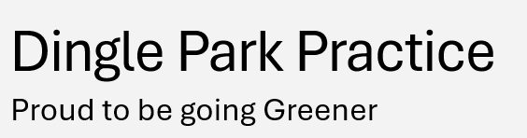
 | The Why |  | What is the Quality Improvement Project (QIP) trying to achieve? Why is this important?  The QIP at Dingle Park Practice aims to reduce the environmental impact of healthcare operations by optimising energy use, improving medication management, reducing plastic and paper waste, and fostering a culture of environmental consciousness among staff and patients. The overarching goal is to contribute to the global effort to combat climate change while enhancing operational efficiency and patient care.  Healthcare contributes significantly to greenhouse gas emissions and waste generation. Addressing these issues is crucial for reducing the sector's carbon footprint and aligning with national and global sustainability goals. By implementing greener practices, Dingle Park Practice not only fulfils its ethical responsibilities but also sets an example in the healthcare community for creating a sustainable future.  What should be measured at baseline and during the project to track progress?  - Energy use: baseline energy consumption from utility bills compared to usage after implementing energy-saving measures (e.g., improved lighting and heating systems).  - Salbutamol prescriptions: number of inhalers prescribed before and after the initiative to reduce over-reliance on rescue inhalers.  - Plastic waste: amount of single-use plastic waste generated before and after introducing reusable water bottles and filtration systems.  - Couch roll usage: frequency and cost of couch roll purchases before and after the initiative to reduce overuse.  - Staff engagement: survey results assessing staff awareness and participation in sustainability efforts.  Include links to wider resources & education on the topic here.  Greener NHS
 | The Wins *
 | Benefit to patients/staff inc. social value |  | Patients:  - Improved asthma management  - Better education on inhaler use  - Proactive healthcare leading to better health outcomes.  Staff:  - Access to sustainable water bottles - promotes hydration and well-being  - enhanced environmental awareness fosters a sense of pride/ shared responsibility. | Efficiency savings | - Reduced energy consumption through optimisation measures.  - Fewer Salbutamol prescriptions due to improved asthma management  - Lowering medication waste.  - Halved couch roll use, cutting associated costs / reducing buying frequency of stock.
Carbon /Ecological benefit |  | - Lower carbon footprint due to reduced energy use and reducing single-use plastics.  - Reduction in paper waste via judicious couch roll usage.  - Environmental benefits from fewer unnecessary medications, including reduced impact of inhaler manufacturing / disposal. |  | Cost savings | - Lower utility bills over time.  - Couch roll costs reduced by 50%.  - Plastic bottle costs eliminated entirely.
 | CQC Area evidenced |  | - Safe: Promoting safer medication practice.  - Effective: Efficient use of resources and sustainable practice operations.  - Responsive: Addressing environmental concerns proactively. | What area from the C&M 10 point green plan for primary care? | - Energy efficiency.  - Waste reduction.  - Sustainable prescribing.
 | The Time |  | Estimated time taken to do the project.  - Carbon footprint audit: 2 months  - Salbutamol review: 4 months  - Plastic waste reduction: 1 month  - Couch roll usage reduction: Ongoing initiative since September 2024.
 | The Who |  | Who is best placed to do the project e.g. clinical (GP, Nurse, Pharmacist), non-clinical (practice manager, admin team), trainee/student  Assistant Practice Manager
 | Stakeholders |  | Who are the key people you need to connect with to make it happen e.g. Patients, GPs, Nurses, Pharmacists, Receptionists, Admin staff.  - Partners  - Management  - All staff  - Pharmacists  - Trainee GP  - Building manager
 | The How |  | The nuts and bolts of how to do the thing, a step-by-step strategy.  Includes IT searches.  Includes patient facing resources.  Includes system to sustain and spread improvements made by the project e.g. further cycles of this QIP  - Energy audit:  - Use the NHS Energy Audit Checklist.  - Identify areas for energy savings and implement measures.  - Asthma management improvement:  - Run IT searches to identify high Salbutamol users.  - Educate patients on proper inhaler use with patient-facing materials.  - Adjust prescriptions where appropriate.  - Plastic waste reduction:  Install a water filtration system.  Distribute reusable bottles to staff.  Couch roll usage reduction:  Train staff on mindful bedroll use.  Monitor usage and stock levels regularly.  System to sustain and spread improvements  Implement regular audits and feedback loops.  Share success stories and best practices across the PCN.
 | How to scale up/down |  | Consider how you might upscale/downscale the project for different levels e.g. GP practice, PCN, locality, ICS  Upscale: Share the initiatives as a case study for PCNs or ICSs. Provide toolkits (e.g., audit templates, patient materials).  Downscale: Focus on one initiative (e.g., asthma management) and expand gradually.
 | Project Contact |  | Credit the person/people who created the project.  Include their contact details if they are happy to be contacted.  Laurie Armstrong - Assistant Practice Manager  Laurie.Armstrong@livgp.nhs.uk

*Please provide the evidence of what you have achieved in each of these ‘wins’ . (e.g. further details of results, descriptions, justifications, tables, figures or photos). You can use for more detail the SUSQI template for more detail that does not fit in above summary: https://www.susqi.org/report-your-experience)

Energy Audit:
Audit done
In recognition of the urgent need to address climate change, Dingle Park Practice has officially declared a Climate Emergency, a statement signed by all partners, managers, staff, and patients. This declaration reflects our shared commitment to reducing our environmental impact and supporting the global movement toward a more sustainable future. As part of our efforts, we have completed a thorough Energy Audit Checklist. This process has provided valuable insights into our current energy usage and highlighted areas where improvements could be made to reduce waste and increase efficiency.

How This Has Helped:
- Identifying Energy Savings: The audit has helped us identify key areas where energy consumption can be reduced, such as optimising lighting, improving heating systems, and minimising unnecessary energy use.
- Cost Reduction: Implementing energy-saving measures will contribute to lowering our utility costs.
- Environmental Impact: By reducing our energy use and carbon emissions, we are making a tangible contribution to lowering the practice’s carbon footprint, which supports our commitment to a greener future.
- Engaging Stakeholders: Involving our staff and patients in this initiative fosters a sense of collective responsibility and encourages environmentally conscious behaviour across the practice.
- By taking these steps, we are not only complying with our ethical responsibilities but also leading by example in the healthcare sector. Together, we are building a more sustainable, eco-friendly practice for the future.

Optimising asthma care
In an effort to improve asthma management and reduce unnecessary medication use, our Trainee GP and Pharmacy Team have collaborated to review the prescription and use of Salbutamol for asthma patients.

Key Actions Taken:
- Prescription Reduction: The team identified cases where patients were over-relying on Salbutamol as a rescue inhaler and have adjusted prescriptions to encourage appropriate use of preventer inhalers, reducing the need for frequent Salbutamol use.
- Stepping Down Treatment: Patients with well-controlled asthma have been guided through the process of stepping down their reliance on Salbutamol reducing overuse.
- Inhaler Technique and Education: By providing patients with training on proper inhaler technique and educating them on how to recognise asthma triggers and symptoms early, this will help to reduce unnecessary Salbutamol usage.
- Reviewing and Streamlining Prescriptions: The pharmacy team has worked to ensure that Salbutamol prescriptions are only provided when truly necessary, with a focus on effective alternatives that provide long-term asthma control.
- Positive Outcomes:
- Reduced Overuse: By prescribing fewer Salbutamol inhalers and encouraging patients to use long-term control medications, we will reduce the frequency of unnecessary inhaler use, which also contributes to minimising medication waste.
- Better Asthma Management: With a focus on proactive asthma control, patients experience fewer asthma attacks and exacerbations, leading to better overall health outcomes.
- Environmental Impact: Reducing the over-prescription of Salbutamol also leads to less waste of inhaler products, contributing to our efforts in minimising environmental impact.
- Cost Efficiency: By prescribing fewer rescue inhalers, we’re also reducing unnecessary healthcare costs, which can be directed toward other areas of patient care.
- This work highlights our commitment to sustainable, patient -centred care, ensuring that medications are used effectively while promoting long-term asthma control.
- Optimising asthma care

Reducing plastic waste
At Dingle Park Practice, we’ve made significant strides in reducing our environmental impact by tackling plastic waste related to bottled water.

Key Actions Taken:
- Water Filter Installation: A water filter has been installed in the kitchen tap, providing clean, filtered water for all staff members to use directly from the tap, reducing the need for single-use bottled water.
- Personalised Eco-Friendly Bottles: We’ve provided each staff member with a personalised, environmentally friendly water bottle equipped with a filter. This initiative encourages everyone to bring their own reusable bottles and eliminates the need for plastic water bottles.

Positive Outcomes:
Massive Reduction in Plastic Waste: Since implementing these changes, we have completely eliminated the use of bottled water within the practice, significantly reducing the amount of plastic waste generated.

Cost Savings: The use of reusable water bottles and a single water filter system reduces ongoing costs associated with purchasing bottled water, contributing to long-term savings for the practice.

Healthier Staff: Having access to filtered water throughout the day promotes better hydration for staff, supporting their overall health and well-being.

Promoting Sustainability: This initiative aligns with our broader commitment to sustainability and sets an example for our staff and patients in reducing plastic consumption and promoting eco-friendly habits.

By making these small but impactful changes, we are not only reducing plastic waste but also contributing to a greener, more sustainable environment for all.

Reducing couch roll usage
In September 2024, our team recognised an opportunity to reduce the environmental and financial impact of couch roll usage in the practice. Although we believed we were already mindful of couch roll consumption, we collectively decided to make a more conscious effort to further minimise waste.

Key Actions Taken:
Reinforcing Awareness: Staff were encouraged to use couch roll more efficiently and only when necessary, without compromising cleanliness or patient care.

Emergency Stock Management: While the NHSPS supplies us with couch roll, we have always purchased additional boxes as an emergency reserve. By reducing usage, we have significantly extended the lifespan of this backup supply.

Positive Outcomes:
Reduced Purchasing Frequency: Previously, the practice purchased additional 2 boxes of couch roll every 2 months at a cost of £40.00 per box. Since implementing this initiative, we now purchase an additional box every 4 months, cutting costs in half.

Environmental Impact: This reduction has decreased the amount of paper waste generated by the practice, contributing to our overall sustainability goals.

Team Collaboration: This success reflects the commitment of the entire team to working together on small, practical changes that have a meaningful impact.

By focusing on mindful couch roll usage, we have achieved measurable savings while continuing to maintain the highest standards of care and hygiene for our patients.

Project 5: Greener Plant Project – Indoor plants. Brownlow Health, Liverpool

Project Title | Greener Plant Project
The Why | What is the Quality Improvement Project (QIP) trying to achieve?  To improve patient and staff wellbeing by introducing indoor plants into GP waiting rooms, while reducing the environmental footprint of the practice and contributing to the NHS Net Zero goals.  This is important as it will help support the following:  - Indoor greenery has been shown to reduce stress, anxiety, and blood pressure, and improve patient experience in healthcare environments.  - Plants improve indoor air quality by reducing CO₂ and pollutants.  - Demonstrates visible commitment to sustainability and greener practice culture.  - Supports the NHS ambition to embed sustainability in everyday operations.  What should be measured at baseline and during the project to track progress? What should be measured at baseline and during the project to track progress?  - Patient feedback: via short waiting-room surveys (e.g. "Do plants make the space feel more welcoming?").  - Staff wellbeing feedback  - Maintenance compliance: regular checklists to track care of plants  Include links to wider resources & education on the topic here: NHS England - Delivering a Net Zero NHS
The Wins
Benefit to patients/staff inc. social value | Calmer, more welcoming waiting environment.  Improved mood and reduced anxiety for patients.  Boosted staff morale through a healthier workspace | Efficiency savings | Potentially smoother patient flow if anxiety is reduced
Carbon /Ecological benefit | Increased awareness of green initiatives among staff/patients | Cost savings | Minimal after initial purchase as plants are low-cost  Potential reduction in energy use (some plants improve humidity and temperature regulation).
CQC Area evidenced | Caring (improving patient experience).  Well-led (commitment to sustainability and staff wellbeing). | Green Impact for Health Toolkit area | Wellbeing for staff and patients  Sustainable premises.
The Time | Estimated time taken to do the project.  Planning & sourcing plants: 2–3 hours.  Regular weekly meeting – 1 hour  Launch Family Event to promote the plants in the waiting room – 5 hours  Maintenance: 5–10 mins per week (watering/checking).
The Who | Who is best placed to do the project e.g. clinical (GP, Nurse, Pharmacist), non-clinical (practice manager, admin team), trainee/student- staff: Site managers admin/reception team for sourcing and care.
Stakeholders | Who are the key people you need to connect with to make it happen e.g. Patients, GPs, Nurses, Pharmacists, Receptionists, Admin staff. Patients (beneficiaries, feedback providers).  Reception/admin staff (plant care).  GPs/Nurses (advocates).  Site Managers  HR /Finance
The How | The nuts and bolts of how to do the thing, a step-by-step strategy.  Includes IT searches.  Includes patient facing resources.  Includes system to sustain and spread improvements made by the project e.g. further cycles of this QIP-Baseline assessment – gather patient/staff feedback on waiting room environment.  Plan & source – choose low-maintenance, air-purifying plants (e.g. peace lily, snake plant, spider plant).  Set-up – place plants in visible but safe spots (avoiding trip hazards). Use eco-friendly pots.  Communicate – share with patients through the Launch event invites and with staff through practice meetings  Monitor  - Weekly plant care checklist  Includes patient-facing resources:  - Posters on benefits of plants.  System to sustain and spread improvements:  - Create a rota/checklist for watering.  - Share project in staff meeting encourage scaling.
How to scale up/down | Consider how you might upscale/downscale the project for different levels e.g. GP practice, PCN, locality, ICS -How to Scale Up/Down  - GP Practice level: single waiting room with a few plants.  - PCN level: scale up and share across all the practices  Also had already initiated a garden in Brownlow Health @ Princes Park - this too could be scaled up
Project Contact | Credit the person/people who created the project. – Michelle Cassidy and Zoe Mc Cue. Overseen by Dr Sarah Nosib sarah.nosib2@livgp.nhs.uk
Top Tip –
Contact building managers for consent if applicable early in the process as this was the step that took longest for us to complete due to slow response times

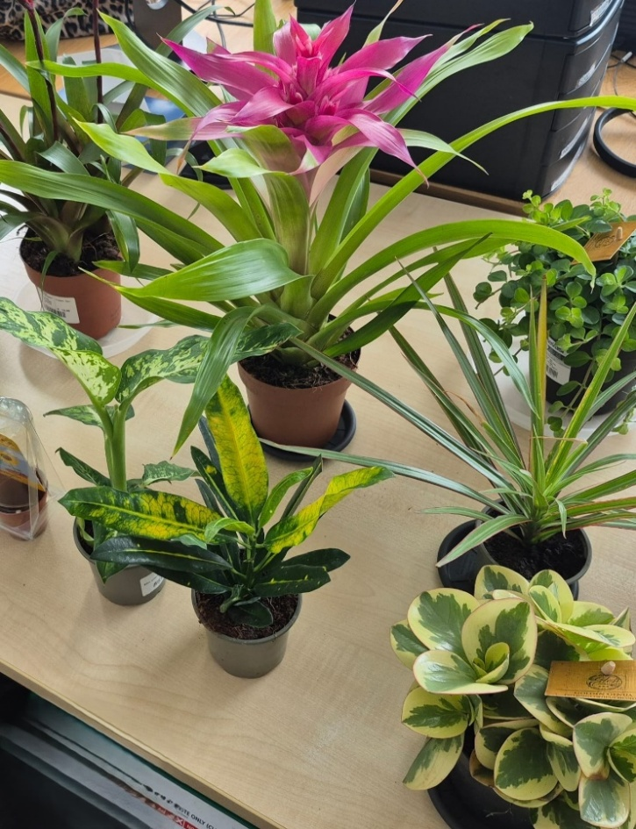
Marybone plants in waiting room

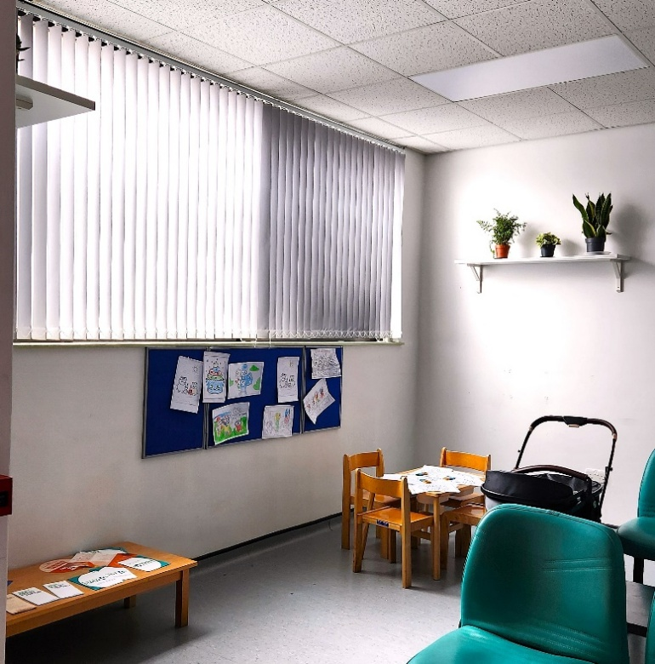

Poster and launch events for Marybone and Kensington practices

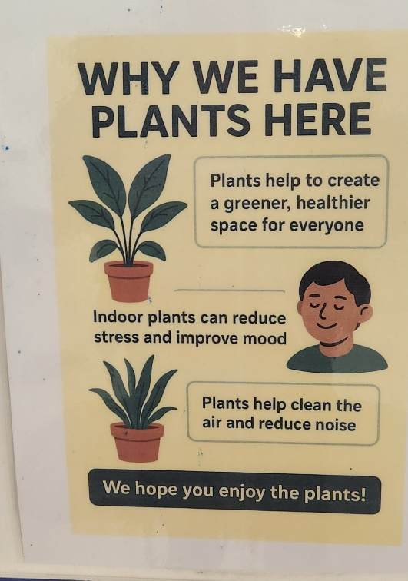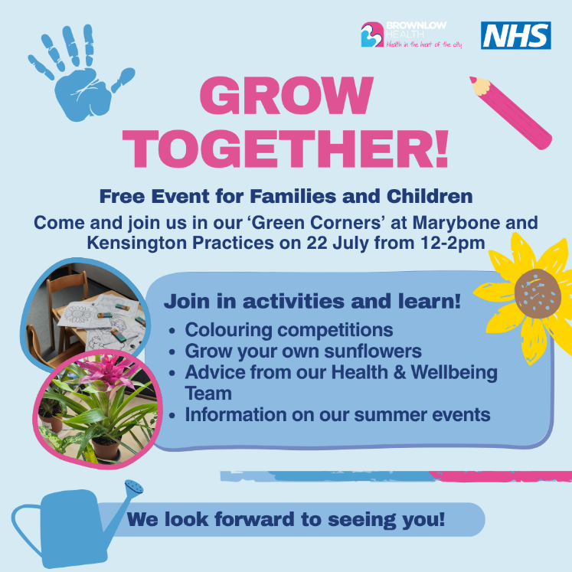
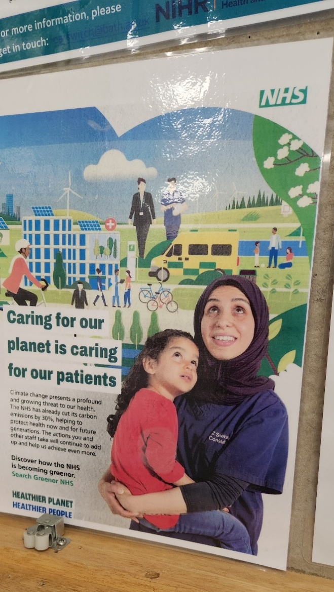

Project 6: Great Sutton Goes Green. Great Sutton Medical Centre, Ellesmere Port, Cheshire

Project Title | Great Sutton goes Green
The Why | What is the Quality Improvement Project (QIP) trying to achieve?  We want to encourage more of our local community to engage with the natural environment.  Why is this important?  Improving the health and wellbeing of patients has a huge impact not only on the wellbeing of those people but the use of the health services to help them. Engaging the community in activities to reduce poor mental health and improve physical health has a huge influence on the use of consumables and their environmental impacts.  What should be measured at baseline and during the project to track progress?  We will be measuring physical activity increases and mental health which has huge impacts across the health economy.  GW Report
The Wins
Benefit to patients/staff inc. social value | Increased physical activity  Mental health wellbeing improvements  7 walks taken place  55 individual participants from the community  15 miles walked | Efficiency savings | Not identified
Carbon /Ecological benefit | 432.34kg CO2e per year  15 trees planted | Cost savings | Not identified
CQC Area evidenced | Effective - this project focussed on achieving good outcomes for participants. | Green Impact for Health Toolkit area
The Time | Estimated time taken to do the project. 20 hours
The Who | Who is best placed to do the project e.g. clinical (GP, Nurse, Pharmacist), non-clinical (practice manager, admin team), trainee/student, Practice Manager
Stakeholders | Who are the key people you need to connect with to make it happen e.g. Patients, GPs, Nurses, Pharmacists, Receptionists, Admin staff. All staff.
The How | The nuts and bolts of how to do the thing, a step-by-step strategy.  Includes IT searches.  Includes patient facing resources.  Includes system to sustain and spread improvements made by the project e.g. further cycles of this QIP  Aim: The proposal for the project is to develop a walking and gardening group that encourages both social and health benefits whilst having a minimal impact on the environment. The walking group was delivered through the Practice Manager’s Community Interest Company.  Outcomes used:  - Walking group:  - Patient outcomes  - Improvements in Mental Wellbeing (SWEMWBS)  - Increase in Physical Activity (attendance survey)  - Environmental Outcomes  - Carbon Footprint CO2 Calculator  - Social outcomes  - Engagement  - Knowledge  - Gardening group  - Social outcomes  - Attendance  - CO2 Calculator
How to scale up/down | Consider how you might upscale/downscale the project for different levels e.g. GP practice, PCN, locality, ICS  this could be rolled out cost effectively by including all GP practices.
Project Contact | Credit the person/people who created the project.  Include their contact details if they are happy to be contacted. James Duckers- James.duckers1@nhs.net

Further project information:

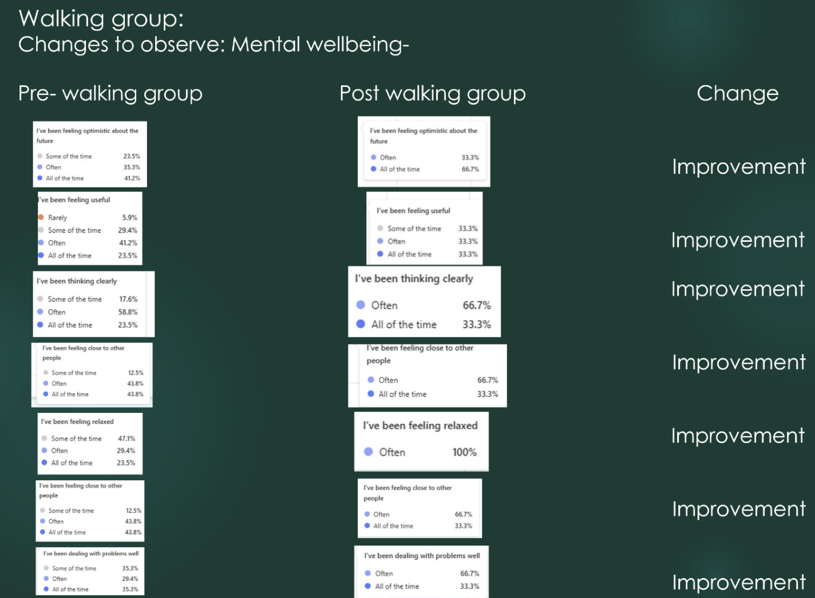
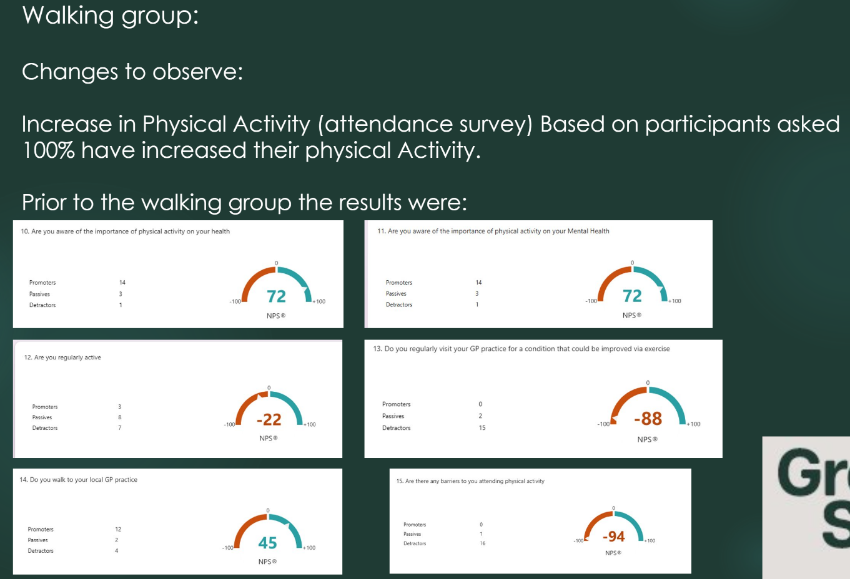
- Results of walking group
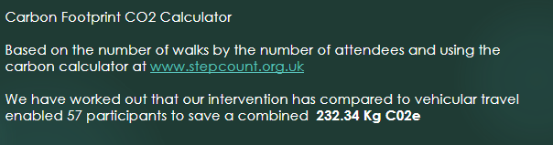
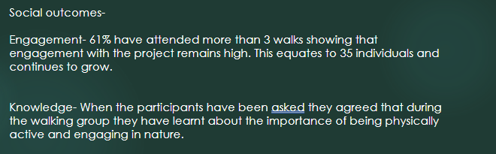

- Results for Gardening group

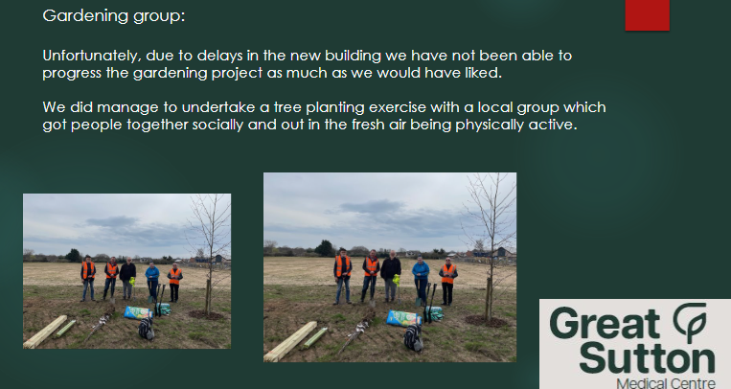

Project 7: Inhaler disposal. Marine Lake Medical Centre, Wirral

Project Title | Inhaler disposal in primary care
The Why | Recent updates to the asthma management guidelines emphasise moving away from the overuse of short-acting beta-agonists (SABAs) and improving patient education. This provided an excellent opportunity to review both our prescribing patterns and the environmental impact of inhaler disposal.  The aim of this project is to improve patient awareness regarding the safe disposal of inhalers and to assess current SABA prescribing habits in our practice.
The Wins *
Benefit to patients/staff inc. social value | Patients: Better asthma control through targeted reviews and increased awareness of safe inhaler disposal  Staff: Reduces unnecessary prescribing and supports up to date guidelines | Efficiency savings | Optimised reviews focusing on high SABA users  Reduced prescribing waste - stopping unnecessary repeat SABA prescriptions.  Promoting proper inhaler disposal helps reduce the carbon footprint, supporting long-term sustainability savings for the NHS.
Carbon /Ecological benefit | Reduces environmental harm from inhaler waste.  Promotes greener healthcare in the community.  Supports the NHS Net Zero targets. | Cost savings | Reduced Medication waste  Prevention of exacerbations by improving asthma control can reduce emergency appointments
CQC Area evidenced | CQC search done looking at patients who have been prescribed 12 SABAs in the last 12 months | What area from the C&M 10 point green plan for primary care? | Environmental Prescribing and Treatment domain of the C&M 10-Point Green Plan (Point 6). Specifically, it touches on:  - 6 a vii: Encourage patients to return old/unwanted inhalers to pharmacies for environmentally safe disposal”  - And more broadly supports the initiative to optimise inhaler use, reduce reliance on high-emission SABAs, and promote responsible prescribing behaviours.
The Time

The Who | GP, nurse
Stakeholders | GPs and Nursing team, patients
The How | Method  - Team Engagement: A meeting was held with the nursing team responsible for asthma reviews to discuss potential interventions.  - Initial Plan: We considered providing a leaflet/poster and installing a dedicated inhaler disposal bin, which would be managed via a local pharmacy.  - Challenges: Local pharmacies were unable to accept inhalers not originally dispensed by them, limiting the feasibility of the bin option.  - Revised Intervention: We developed a patient information poster focusing on safe inhaler disposal, signposting patients to appropriate disposal routes.  - Prescribing Audit: A search on EMIS identified 26 patients who had been requesting SABA inhalers monthly for the past year.  - Action: The nursing team prioritised these patients for review to assess asthma control and ensure appropriate prescribing. Some were found to be over-ordering simply because SABAs were on repeat without regular assessment.  Additional Opportunities  Although I had planned a knowledge update for the clinical team regarding asthma management and the recent guideline changes, a colleague is already arranging this. Nevertheless, this remains a timely and valuable learning opportunity.  Outcome  - Patients are now better informed about inhaler disposal through the new poster.  - A targeted review process has been initiated for patients potentially overusing SABAs.  - Ongoing work is in place to support clinical staff in updating asthma management knowledge.
How to scale up/down | - PCN: Share poster and materials across all practices or run joint asthma education sessions.  - Locality: Partner with local pharmacies to explore shared inhaler return pathways.  - ICS: Standardise inhaler disposal education materials across the region. Negotiate pharmacy involvement at scale for inhaler returns.
Project Contact | Dr Azhar Khan

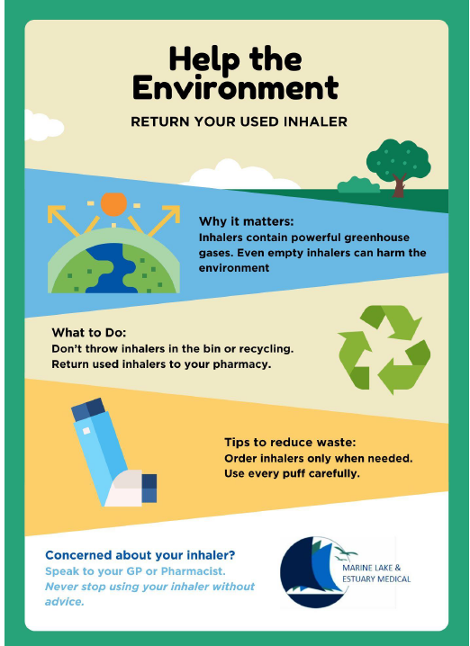
*Please provide the evidence of what you have achieved in each of these ‘wins’ . (e.g. further details of results, descriptions, justifications, tables, figures or photos). You can use for more detail the SUSQI template for more detail that does not fit in above summary: https://www.susqi.org/report-your-experience)

Additional plans progress:

- Check the solar installation –still to be checked
- Couch roll / gloves off - on hold
- The practice already uses reusable tourniquets and subscribes to SharpSmart
- Engaging with staff and patients and updating them on achievements
- CSH training completed

Poster created for the project and put up in the practice

Project 8: Asthma project. Rock Court Surgery, Liverpool

Project Title | Asthma Project 2024/2025
The Why | What is the Quality Improvement Project (QIP) trying to achieve?  This project was aiming to improve asthma care in our practice population, with the overriding goal to reduce the overuse of short acting beta agonists (SABA) in our patients with asthma.  Why is this important?  A key learning point from the National Review of Asthma Deaths in 2014 was that people with asthma should have a personalised asthma management plan and appropriately managed exacerbations. One of the indicators of poor asthma control is the overuse of SABA. Evidence shows that SABA overuse is correlated to admissions and exacerbations (JAMA 2022; 328-575).  The BTS/NICE/SIGN guidance has updated guidance of SABA and states do not prescribe SABA to patients with asthma of any age without concomitant ICS. In addition, it recommends that patients aged 12 plus with uncontrolled asthma should have their treatment changed to a non-SABA regimen.  Moreover, overuse of inhalers impacts the environment with inhalers accounting for 4% of the NHS carbon footprint (DTB 2022; 3:34) The NHS has committed to reducing its carbon footprint by 80% by 2028-32. A reduction in prescribing MDI SABA inhalers will in turn reduce NHS carbon footprint.  What should be measured at baseline and during the project to track progress?  The amount of SABA prescribing should be measured at baseline and during the project to track progress.  Include links to wider resources & education on the topic here.  The ideas and structure of this project was largely based on: -  - Those in the toolkit developed by Greener Practice on ‘High Quality and Low Carbon Asthma Care’ - https://www.greenerpractice.co.uk/high-quality-and-low-carbon-asthma-care/  - Dr Mark Levy’s 7 step plan to reduce asthma deaths in 2024 - Dr Mark Levy 7 step plan
The Wins *
Benefit to patients/staff inc. social value | Benefits for patients would be improved asthma care which in turn would reduce asthma attacks, hospital admission due to asthma attacks and deaths from asthma. By improving asthma control there would also be improvement in quality of life and wellbeing for patients.  The benefits to staff would be agreeing standards of care, providing up to date education in asthma management. It was also found that coming together as a team to improve asthma care improved morale! One of the nurses fed back after the education session to say she felt she had a ‘spring in her step’! | Efficiency savings | This project led to:  A 34% reduction in SABA prescribing for those patients without a diagnosis of asthma or COPD of 34%.  There is a marked improvement in coding ‘suspected asthma’ or suspected COPD - jumping from 16% to 52%.  A 14% reduction in the number of patients requesting 6 or more SABA inhalers in the preceding 12 months.  A 14% increase in the proportion of patients coming in for asthma reviews.  A 233% increase in the proportion of patients being contacted about their excess SABA use.  A 212% increase in the proportion of patients being switched to a MART regimen. This does not include those already switched to MART who are no longer requesting more than 6 x SABA.
Carbon /Ecological benefit | The amount of salamol inhalers issued for patients with asthma in the month of April 2024 in Rock Court was compared to that prescribed in the month of April 2025.  April 2024 = 133 salamol inhalers  April 2025 = 85 salamol inhalers  A reduction of 36%  Carbon footprint of salamol inhaler = 10kgCO2e  Reduction carbon footprint April 2024 compared to April 2025= (133-85)x 10 = 480kgCO2e  Therefore, estimated reduction over 12 months = 12 x 480 = 5760 kgCO2e  This does not take into account better control of asthma leading to decreased hospital admission / GP attendance and multiple additional factors that come with improved quality of life. | Cost savings | The amount of salamol inhalers issued for patients with asthma in the month of April 2024 in Rock Court was compared to that prescribed in the month of April 2025.  April 2024 = 133 salamol were issued  April 2025 = 85 salamol were issued  Reduction of 36% SABA prescriptions  Cost of salamol inhaler = £1.46  Reduction in cost in April 2025 compared to April 2024 = (133-85) x 1.46  = £70  Estimated cost reduction over 12 months = £840.96  This does not take into account better control of asthma leading to decreased hospital admission / GP attendance and multiple additional factors that come with improved quality of life.
CQC Area evidenced | Effective  Response to needs  Well led | What area from the C&M 10 point green plan for primary care? | Item 6 – Environmental Prescribing and Treatment
The Time | 9 months
The Who | GPs and Pharmacist
Stakeholders | Dr RC Sammut, GP  Dr K Evans, GP  Dr Ball, GP Partner  Kiera Clare, Pharmacist.
The How | 3 baseline audits were carried out for our asthma patients:  - Looking at all patients diagnosed with asthma who had been prescribed 6 or more SABA in the last 12 months to find out if they were up to date with their asthma review, if they been contacted about their SABA requests, and what treatment they were on.  - Looking at patients on SABA without a diagnosis of COPD or asthma the purpose being to see how patients with suspected asthma were being managed, coded and followed up.  - Looking at those patients who had been seen following an asthma exacerbation, how were they being managed, coded and followed up.  Interventions that took place following the above baseline audits:  - Process for SABA overuse was agreed and implemented (please see attached).  - A pathway for patients after asthma exacerbation (please see attached) had been agreed.  - From October 2024 to January 2025 searches were carried out to see if patients were being reviewed after presenting with an asthma exacerbation. If they had not been seen they were invited to come in to review their asthma management.  - A pathway for asthma diagnosis had been agreed (please see attached).  - An education session took place involving the clinical team to communicate the audit findings, update asthma guidelines, and agree recommended changes to practice.  - Appointment slots (6 each week) were allocated for asthma reviews with a GP interested in asthma.  The audit on patients prescribed SABA without a diagnosis of asthma and COPD and the audit on SABA overuse were reaudited to see the impact of the changes that had been made to clinical practice.
How to scale up/down | To downscale this project a team could chose to focus on one element at a time:  - Focus how the practice follows up patients after presenting with an asthma exacerbation  - Focus on how the practice is tackling SABA overuse and switching to MART regimen where appropriate.  - Focus on asthma diagnosis  - Holding an education session around asthma for the clinical team.  - Increasing availability of appointments either with GP / asthma nurse or pharmacist for asthma reviews to tackle SABA overuse.
Project Contact | Dr RC Sammut  rebecca.sammut@livgp.nhs.uk

Project 9: Streamlining routine chronic disease blood tests. Weaver Vale Surgery, Winsford, Cheshire

Name of GP practice: | Weaver Vale Surgery
GP practice ODS code: | N81127
Name and role of the person completing the form on behalf of the contractor | Anastassia Volkov

Project Title | Streamlining ordering of routine chronic disease blood tests
The Why | The project aims to reduce the number of separate occasions a patient attends for a blood test for routine testing required for chronic disease management. Also, to avoid unnecessary duplication of the same blood test, e.g. cholesterol, when patient is on more than one chronic disease register.
The Wins *
Benefit to patients/staff inc. social value | Fewer patient contacts Improved patient care - avoid missing tests | Efficiency savings | Time saved for patients. staff, and laboratory staff, time saved for clinicians in taking bloods and assessing results
Carbon /Ecological benefit | Fewer carbon emissions due to reduced travel, reduced paper and materials and the processes of testing | Cost savings | Fewer tests = less financial cost to NHS Saves money for patients on transport, and lost working hours
CQC Area evidenced | Improved and more efficient patient care. Comprehensive review of a patient care pathway. | What area from the C&M 10 point green plan for primary care? | 4 - embed the 3 R’s  6 - Environmental prescribing and Rx
The Time | Main work, writing the protocols, sharing and education was until end on March beginning of April
The Who | Practice pharmacist and admin staff
Stakeholders | Clinicians, admin. Project implemented by a pharmacist
How to scale up/down | Report will be written and shared through PCN and wider afield depending on results
Project Contact | Anastassia Volkov

*Please provide the evidence of what you have achieved in each of these ‘wins’ . (e.g. further details of results, descriptions, justifications, tables, figures or photos). You can use for more detail the SUSQI template for more detail that does not fit in above summary: https://www.susqi.org/report-your-experience)

Background:
The practice currently manages approximately 1,500 patients of all ages who are living with two or more chronic disease diagnoses. Blood test monitoring for these patients is coordinated by 4–5 administrative staff members, each responsible for specific long-term conditions. As a result, patients are often invited multiple times throughout the year (sometimes two to four times) to complete their required blood tests.

This fragmented system results in:
- Duplicated tests (e.g. cholesterol testing for both diabetes and coronary heart disease)
- Inefficient use of administrative and clinical time
- Increased patient travel, contributing to higher carbon emissions
- Unnecessary use of healthcare resources and consumables
- Avoidable financial costs to both primary and secondary care services

Considering these inefficiencies, a decision was made to trial a more streamlined approach by consolidating all blood test monitoring into a single annual appointment per patient.

Specific Aims:
The primary aim of the project is to improve the sustainability and efficiency of chronic disease monitoring within the practice by:
- Reducing the number of blood test appointments per patient per year through test consolidation
- Minimising duplicated blood tests across long-term conditions
- Reducing patient travel and associated carbon emissions
- Decreasing demand on clinical time and consumables
- Identifying opportunities for financial savings in primary and secondary care settings

Methods:
To support the consolidation of blood test monitoring, a simplified protocol was developed and implemented across the clinical team. Anastassia created a clear, one-page A4 chart outlining the required blood tests and their recommended frequency for each chronic condition. This concise and accessible format was designed to ensure consistency in test requesting and to reduce duplication.

Anastassia delivered educational sessions to the admin team, nurses, healthcare assistants (HCAs), and GPs during scheduled clinical and one-to-one meetings. These sessions explained the rationale for the project, how to use the chart effectively, and how to identify patients suitable for consolidated reviews. A printed copy of the protocol was provided to each clinician and admin team to keep by their computer for ease of access during patient encounters.
Measurement:
To evaluate the efficacy of the intervention, Anastassia conducted a retrospective data analysis employing EMIS searches. The population met the predefined criteria, comprising 1,500 patients. However, it was determined to manually analyse only 150 patients (representing 10% of the population). The frequency of blood test appointments and the range of blood test sets requested per patient were scrutinised both prior to the protocol’s implementation and several months thereafter. This analysis sought to identify:
- A diminution in the number of patient visits for blood tests
- A reduction in the occurrence of duplicated or superfluous blood panels
- Overall enhancements in efficiency and resource allocation

Results
Although this project is still in its early stages of implementation, with only just over two months of active use, preliminary observations suggest positive directional change across several domains. The protocol was rolled out and supported by structured staff training, accessible resources, and close monitoring. While full impact will only be visible at the end of the financial year as more patients complete their monitoring cycles, emerging qualitative and early quantitative insights indicate that the intervention is beginning to make an impact.

1. Patient Outcomes
While it is too early to assess long-term clinical outcomes, anecdotal feedback and preliminary record reviews suggest a reduction in unnecessary testing and repeat visits. Early blood test requests show that clinicians are more targeted in their ordering, aligning test panels with the patient’s actual conditions as outlined in the new protocol. This suggests a move towards safer, more personalised care, reducing the burden of multiple appointments and invasive tests for patients.

2. Population Outcomes
The cohort of 150 patients analysed (10% of the total target group) has provided a valuable test bed for the new protocol. Analysis of recent EMIS records shows an emerging trend toward consolidation of blood test appointments and greater adherence to guideline-based monitoring. If this trend continues, there is potential benefits in terms of improved care coordination and reduced service fragmentation.

3. Environmental Sustainability
Although a full environmental impact too early to identify, early reductions in duplicate blood testing already point toward a likely decrease in clinical waste, single-use equipment (e.g. vials, syringes, PPE), and patient transport emissions. By reducing the number of blood tests and appointments required per patient, the intervention has the potential to significantly cut the carbon footprint of chronic disease monitoring in primary care.

4. Economic Sustainability
Cost savings are anticipated through reduced duplication of tests and fewer clinical appointments. While these savings cannot yet be fully quantified, EMIS searches comparing pre- and post-implementation data have shown fewer blood test requests per patient. This is likely to reduce pathology processing costs and staff time associated with phlebotomy and administration.
5. Social Sustainability
This project has fostered a strong culture of collaborative working and shared responsibility within the practice. Significant time and effort were invested in protocol development, educational sessions for clinical staff, and the creation of simple, accessible tools to support consistent implementation. Clinicians have responded positively, and the standardised approach is contributing to improved workflow, greater confidence in decision-making, and more equitable care delivery. These cultural shifts are essential for embedding sustainable practices in the long term.

Discussion
This project demonstrates a proactive and systematic approach to addressing inefficiencies in chronic disease monitoring within primary care. The current model, which often results in multiple invitations and duplicated tests, places unnecessary strain on patients, staff, and NHS resources. By developing a clear, one-page protocol and delivering targeted educational sessions to clinical staff, this initiative has taken a practical, scalable step toward more sustainable, person-centred care.
Initial engagement from the multidisciplinary team has been positive, with clinicians appreciating the simplicity and clarity of the protocol. The educational sessions played a key role in embedding the new process, and the availability of the guidance sheet in each consultation room has made adoption more accessible.

While the project is still in its early stages, early signs of change—such as more appropriate test requests and reduced blood test duplication—suggest that staff are beginning to internalise the new approach. The use of EMIS searches to analyse patterns in blood test requesting has been valuable in capturing emerging trends, even before actual outcomes can be measured. However, it’s important to acknowledge the current limitations. Most chronic disease monitoring follows an annual or six-month cycle, so measurable outcomes may take time to fully emerge. Additionally, analysing only the 10% pilot population may not yet fully reflect the challenges and variability of the entire cohort of 1,500. Nevertheless, the foundation has been laid for a change in practice that is both clinically sound and aligned with the broader NHS goals of environmental and financial sustainability. This work also highlights the role that clinical pharmacists can play in leading sustainable, system-level change within general practice.

Conclusions:
This early-stage project represents a meaningful step toward more efficient, patient-centred, and sustainable chronic disease management in primary care. Through the development of a streamlined protocol and investment in staff education, the groundwork has been established for long-term change.

Although full results are not yet available, initial observations suggest improvements in the appropriateness of test ordering, reduced duplication, and better use of healthcare resources. The project also supports wider sustainability goals by potentially lowering carbon emissions, reducing waste, and improving workflow.

As the monitoring cycle progresses and more patients are monitored using the new protocol, further benefits become apparent. If these early trends persist, this approach has the potential to be scaled up, shared across PCN and other practices, and make a significant contribution to NHS environmental and economic sustainability targets. Ongoing staff collaboration will be key to maintaining momentum and ensuring the success of this initiative.

NB: 1 year audit planned in May 2026. Results will be available then. Issues with a slower start, the difficulty of getting projects underway in a busy environment.

Document created by Weaver Vale Surgery to inform clinicians and staff of routine LTC blood monitoring

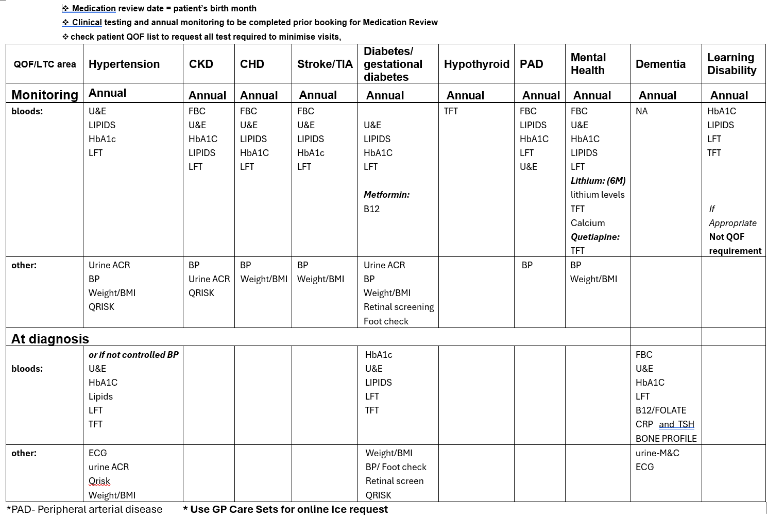

Project 10: Elms Green Plan. The Elms Medical Centre, Cheshire

Project Title | Embedding Green Impact into the organisational culture by maximising engagement and promote understanding of the climate and health emergency.
The Why | What is the Quality Improvement Project (QIP) trying to achieve?  Project A – Streamlining of blood tests for LTC and medication reviews to reduce the travel for patients.  Project B -Inhaler recycling in partnership with Wells Pharmacy  Project C -Iron De-prescribing  Project D -inhouse recycling schemes for coffee grounds for allotments, recycling of toners, reducing single use plastic & food waste recycling.  Why is this important?  Making sustainability one of our core values. Engage the team to reflect on how they can help sustainability within the practice and their households. Improving our Energy Efficiency. Implement a “Buy Green” policy. Reducing waste and increase recycling. Reduce over-prescribing. Support health and wellbeing with the team.  What should be measured at baseline and during the project to track progress?  Reduction in number of appointments.  Calculating the carbon footprint  Safer prescribing  Communication with staff on what has been recycled  Staff well being  Patient satisfaction results
The Wins *
Benefit to patients/staff inc. social value | Staff and patient satisfaction | Efficiency savings | Awaiting data analysis
Carbon /Ecological benefit | Awaiting data analysis | Cost savings | Awaiting data analysis
CQC Area evidenced | Yes | What area from the C&M 10 point green plan for primary care? | Declaring the climate crisis  Environmental prescribing  Engage and empower patients  Monitor and reduce energy waste  Make use of green impact toolkits  Embed the “3 Rs” into the culture
The Time | 10 months
The Who | Green Project lead GP and practice manager. Other members of the team have also contributed.
Stakeholders | Patients, Suppliers, community Pharmacy and auxiliary staff like phlebotomist.
The How | Project A – Using the Ardens blood test analyser and creating a lab result protocol for the staff to follow. Practice saw 23% reduction in LTC blood test appointments in a period of 4 months.  Project B – We partnered with Wells Pharmacy to promote recycling of inhalers to our patients. We used posters, added messages on repeat prescriptions and also provided a recycling bin on our reception desk where patients can drop off their used inhalers. This has been a great success in practice and the success is seen in the increased amount of recycling we are doing each month.  Project C – We held an education session with the clinicians in our PLT in the benefits of changing to the new iron prescribing guidance. When we re-audited in September 2025 we saw a reduction of 57% in our iron prescribing compared to the baseline figures.  Project D – We partners with our facilities management company who provided food recycling bins and initiated recycling of food waste with B&M waste company. We have a lead admin staff member who is responsible for contacting the recycling company for collection of toner and cartridges. This is promoted by posters in the staff room and also stickers on all the printers.
How to scale up/down | We will upscale the safer prescribing scheme to include Fostair project & Group asthma inhaler technique clinics for young adults.  We will upscale the non-clinical single use project by introducing “No Gloves” project.
Project Contact | Everyone at Elms have contributed towards the success of these projects.  The elms have also been shortlisted for the Sustainability in Practice ~Award 2025 this year for the work we have done to become more sustainable and greener.    We have seen the following benefits this has made to the team:  - Improved Workplace Wellbeing  Sustainable changes, such as better ventilation, natural lighting, green spaces, and reduced reliance on harsh chemicals, have contributed to a healthier, more pleasant working environment helping towards reducing stress and sick days.  - Increased Engagement and Morale  Involving staff in green initiatives has fostered a sense of pride and purpose. Many team members feel more connected to their values, leading to improved morale and team cohesion.  - Operational Efficiency  Greener processes (e.g. going paperless, digital triage, and remote consultations) have reduced administrative burden and increased time for patient care, helping towards improving job satisfaction and reducing burnout.  - Professional Development  Staff have gained knowledge in sustainable healthcare practices, enhancing their skills and contributing to their personal and professional growth.  The benefits to our patients have been:  - Healthier Environment  A cleaner, more sustainable practice environment directly supports patient health, especially for those with respiratory issues, allergies, or sensitivities. Reduced pollution and improved air quality in and around the practice benefit vulnerable groups.  - More Accessible, Flexible Care  Digital innovations driven by sustainability (e.g. remote consultations and online forms) offer patients more convenience, reducing unnecessary travel and associated stress or emissions.  - Trust and Transparency  Patients increasingly value sustainability. By openly committing to greener practices, the practice builds trust and strengthens the relationship with its community.  - Preventative Health Focus  Sustainable practices often go together with a holistic approach to health. The practice’s emphasis on encouraging activity, diet, and air quality not only lowers carbon impact but promotes healthier lifestyles.  - Optimising prescriptions  By promoting wastage in medicines, deprescribing and educating patients on their use of medications (better inhaler techniques) we are helping reduce the carbon footprint locally.  Overall, sustainability has enhanced the way care is delivered, making the practice more resilient, future-ready, and better aligned with both staff values and patient needs.

Appendices

Appendix 1: Greener Practice/ ICB Primary care projects application form and notes

Business Case Form: Greener Primary Care Projects –
a collaboration between the Cheshire and Merseyside (C&M) ICB
and the C&M Greener Practice group

Project title:
PCN / Practice name:
Submitted by:
Date submitted:
Summary of project:

Background / context:

Current position:

Proposal:

Alignment to C&M 10 Point Green Plan for Primary Care priorities / programmes:
(e.g. models of care; workforce; medicines; climate adaptation and mitigation, etc. https://www.cheshireandmerseyside.nhs.uk/media/hahluufe/10-point-plan-for-primary-care.pdf)

Explain what Benefits/ outputs/ outcomes/ cost savings the project is anticipated to have:
(Keep this simple, do not worry if you can’t develop this section.)

Explain how you anticipate the project will reduce carbon emissions and outline the method for measuring environmental and social impact, (such as conducting a carbon footprint analysis before and after project implementation).
(Below are suggested tools you can consider using. Keep this simple, do not worry if can’t develop this section. This can be looked at once the project is started with your supervisor.
Carbon emissions can be estimated/ calculated from the following:
- https://seesustainability.co.uk/carbon-footprint
- https://sustainablehealthcare.org.uk/what-we-do/carbon-footprinting-and-triple-bottom-line-analysis
- MCF classifier for carbon footprinting medicines https://www.yewmaker.com/mcf-classifier

Measuring impact:
- Choose varied outcomes (cost, quality outcomes, environmental and social outcomes)
- Sustainability network susQI framework for social/ environmental impact. https://sustainablehealthcare.org.uk/susqi)

Staffing (you may want to involve staff from the broader primary care team and possibly patients):

Project milestones and Timeframe

Task | Lead/ s | Date of completion
i.e. PCN data gathering exercise to inform project scope

Funding sought (brief expenditure plan and itemised costs) (budget must be between £500 and £2000):
(Suggested headings:
- staff/ manpower
- equipment/ consumables
- printing/ communications/ dissemination)

Dissemination plans (These do not have to be extensive. Think of who would be relevant to present the findings to, or if a training package, cascading of information is possible electronically, and publication, etc)

Reviewers:
This document must be reviewed by the following people:

Reviewer Name(s) | Title / responsibility | Date

Approved by:

Date agreed:
Why should I apply to be a Green Champion, why sustainability in primary care?
Planetary Health and Human Health are inextricably linked and the climate crisis is one of the biggest crises of our era. We have 10 years for the Earth to become carbon neutral, before the Earth heats up to become even more uninhabitable. We need to act now in all sectors which are not carbon neutral. The NHS, being a large employer in the UK, comprises 4% of the national carbon footprint. The UK is the only health service to have pledged to reach net zero by 2045. For this we need to tackle clinical and non-clinical carbon footprints in all aspects of healthcare. Cheshire and Merseyside ICB have a 10 point green plan for Primary Care. This funding is linked to implementing it.

We would like to encourage anyone from the primary care team to apply, whether a clinical or non-clinical member of the team! The aim is to support any local ideas to attain NHS net Zero! Sustainability projects are win-win-wins: they usually have three benefits:
- improved quality of care,
- cost savings and
- reducing the carbon footprint.

Notes on completing the form
In this form, please explain briefly what motivates you to be involved, what experience you have had, and what ideas you would like to develop. Please keep your proposal simple. If there are items on the form that seem difficult (like carbon footprinting or costs of drugs) then do not worry about filling this in, and we can figure it out during the project with your supervisor. We would like IDEAS rather than fully formed projects.

Attached is a list of feasible proposed projects you may choose or adapt to your practice(s)/PCN (appendix 1). You may choose to implement this/these projects in your surgery, or several GP practices, with a view to be scaled up across the PCN, or a PCN-wide action from the start. We will consider different ideas though we would have to make sure it aligns with our capacity to support with this project.

We request that the applicant/ potential new green champion who is submitting this application should include Action 1 and then choose 1 (or more) of the further actions (2-6) for a 6 month project. You may wish to consult your other practices to create your proposal. The proposal you submit now does not have to be fully thought out and planned, nor have received practice/PCN approval. It needs to have a justification of what you envisage you could do, are in the process of finding out, and why you want to implement it. Once selected, a member of our sustainability team will support with refining the project, make sure it is feasible, the strategies to achieve these, and directing you to relevant tools, documentation, templates etc, which we have access to as these are projects that we, or other Greener Practice members have performed.

Please submit this form by 27th September 2024 to candmgreenerpractice@gmail.com. We will know if you are successful by early October. If you have any queries about the funding you may also contact us at the above email address.
What is expected of you if you get the funding:
- To become a Green Champion for your practice and/or PCN.
- To deliver a project (along sustainable quality improvement framework) which would be either PCN wide or one / a few practices.
  - 6 months (from October/early November 2024; completion anticipated April 25)
  - aligned with the 10 point C&M plan (main items visible in Figure 1).
  - produce a report at the end (format provided) with quality care, cost and carbon footprint outcomes

What you can expect from us:
- supportive/ supervisory meetings (to advise on project development and implementation/ linking with stakeholders)
- provision of carbon literacy training if you have not had any already
- funding for the projects: we will consider a budget of £500 to £2000.

Figure 1: The 10 point green plan for primary care in Cheshire and Merseyside

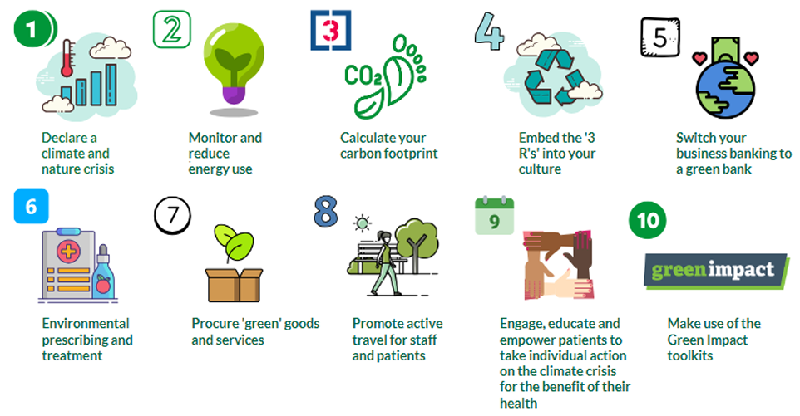

APPENDIX 1: SUGGESTED PROJECTS
Below are the suggested projects with potential impacts.

Action/ project | Contribution to the Primary Care 10 Point Green Plan | Net Zero Plus impact | Patient impact | Cost impact | Health service impact | PCN/GP | Ease/ feasibility considerations
Action 1:  Have a discussion within the practice team to maximise engagement and promote understanding of the climate and health emergency | 1.Declare a climate and nature crisis | Catalyses energy audit and carbon footprinting  Highlights ecological health.  Anchor charter links this to social justice and equity. | Improved patient engagement | neutral | Improved staff engagement | Each practice within the PCN. May consider the more holistic Anchor Charter | Easy –  Setting up a discussion within the practice involving as many staff as possible, As an option you may want to consider declaring a climate emergency (which would need GP partner backup):  all tools/ standard forms/ information packs available.
Action 2:  Switch your business banking provider to a Green bank | 5.Switch to a green bank | Huge carbon impact (disinvesting in fossil fuels). Cuts carbon 21x more than becoming vegetarian, giving up flying and switching energy provider put together. | Neutral at point of delivery, longer term impact on global human health | May have upfront cost to change (if use Mothertree to help) | Neutral – some work needed from finance team and partners | Each GP practice needs to make an individual decision. Can be encouraged at PCN level. Can encourage staff to change their personal banking too. | Very worthwhile and impactful. May need upfront investment but much help with the difficulties of switching taken on by Mothertree. All contacts available to help as we have practices currently doing this who could support.
Action 3:  Working on greener inhaler prescribing  (see potential projects below*) | 6.Environmental prescribing and treatment | Largest carbon footprint reduction for single item (MDIs=13% of primary care clinical footprint; 20% of total carbon footprint) | Shift to low carbon inhalers Top NHS net zero priority | Cost neutral | Associated with better asthma/COPD control; will help GP practices implement new BTS/SIGN guidelines | Deliverable at practice level by PCN team e.g. (network pharmacists). Needs nurse engagement and a lead at PCN to maintain momentum, training etc. | This has worked well when practices aware of what their figures are progressing (competitive across PCN). good as QIP for trainers/ students/ GPs
Action 4:  Safer prescribing and appropriate deprescribing “first do no harm”  (further project ideas below*) | 6.Environmental prescribing and treatment | 60% of carbon footprint in primary care (incl inhalers) | Deprescribing is a top NHS net zero priority; engagement of patients; | Big cost savings | Reduces hospital admissions, mortality and adverse side effects, reduces polypharmacy | Needs network pharmacists involved. Whole prescribing team/GPs also to be trained. Staff satisfaction high | Positive examples and written up QIPs as examples. Polypharmacy reviews are a priority and these projects can improve them/ help the deprescribing aspect
Action 5:  Undertake an energy audit and calculate a carbon footprint of your practice.  OR sign up to do bronze award of GIHToolkit | 2.monitor energy use  3. calculate carbon footprint  10. make use of green impact toolkits https://greenimpact.nus.org.uk/green-impact-for-health/ | 15% of total primary care footprint | High net zero priority | Cost savings from reduced energy use, building improvement, going paperless etc | Neutral at point of delivery but will help develop solutions like using renewables, adapting practices to be climate resilient | Needs clinicians, admin practice managers, organisational teams, procurement, building managers involved. Whole team approach. Can be set up as competition across PCN. | Whole team approach. Needs meetings to discuss what to do/ how to respond. Suggestion to be done in a stepwise fashion. Does not all have to be done at once! Practices to choose what to focus on first. The GIHT award system is good to give step wise suggestions and awards help motivate change.
Action 6:  Active travel  OR  Green/ Blue Spaces  (e.g. Gardening projects, physical activities outdoors, air quality monitoring and interventions) | 8. Promote active travel for Staff and patients.  9. Engage/empower patients to take action  10. Make use of Green Impact Toolkits | Travel is 30% of Primary Care Emissions.  Lack of green spaces is associated with health inequalities. | Active travel and Green spaces lead to pollution reduction, improved physical health, mental health and wellbeing | Upfront cost for different infrastructure. Long term, cost savings from chronic disease reduction. | Improved staff and patient wellness; long term reduction in chronic disease burden; integration with social prescribing/ health coaches. | Implementable as practice-specific or PCN-wide. | Green spaces: success in Central Liverpool PCN: 4 practices with community gardens/ linkage with ARRS.  Active travel: Good action going on within ICB/ public health/ council levels. Limited success in C&M GP practices. However positive examples in Cornwall.

*Action 3: Greener respiratory care - further project ideas (in bold the ones C&M Greener Practice has identified as most important)

Comprehensive change to inhaler prescribing:  - Optimise asthma reviews to  -target optimal preventer inhaler use  -ADOPTION of the new GINA guidelines with AIR/MART therapies (increasingly the basis for most local guidance)  - Encourage use of appropriate inhaler technique e.g. using placebo devices and promoting the Rightbreathe app and website.  - Consider environmental impact at each respiratory review.  - Encourage patients to return old/ unwanted inhalers to pharmacies for environmentally safe disposal.  - to use combined preventer/reliever DPI therapy e.g. Fobumix easyhaler. Preventer inhalers are often low-emission dry powder inhalers (DPIs) and improve overall asthma care. | Most comprehensive, will be part of the plan soon nationwide. Needs training and support, and reinforcing as is a new way of delivering asthma care (art/mart). Would make sense to start once the guidelines come out.
Addressing overuse:  - Reduce high usage of reliever inhalers (6+ prescriptions annually). In addition to the health risks associated with reliever over-use, reliever inhalers tend to be high emission MDIs. E.g. Greener Breaths project to change how SABA prescribed (on acute), and doing education at each review. More careful prescribing of preventers on repeat. Having posters/ messages on message board/screen in waiting room. Texts etc. | Overuse and overordering is half of the carbon footprint from inhalers. 83% of SABA prescriptions linked to overuse. Important to address as also is associated with negative patient outcomes. High patient and carbon impact.
Focussing on targeting certain groups to reducing carbon footprint:  - Reduce the percentage of non-Salbutamol inhalers prescribed as MDIs.  - Optimise prescribing to prioritise lower emission Salbutamol inhalers. i.e. prescribe specific lower emission MDIs such as Salamol.  - Review a subset of patients with prescriptions for high carbon inhalers (i.e. Flutiform MDI, Symbicort MDI,).  - Set up a system for review of patients on high carbon footprint inhalers, Flutiform MDI (£28, CO2e 37kg) and Symbicort MDI (£28, CO2e 37kg) and Ventolin Evohaler MDI. Employ shared decision making to explain the environmental benefits of changing to lower carbon footprint inhalers without losing disease control. Provide evidence via open prescribing that your numbers are decreasing. (Preventer inhalers are usually issued every month. Changing to Luforbec or Fobumix will save approx. £7 per month)  - Review patients on DPI treatment (preventer) inhalers and MDI rescue (reliever) inhalers. It is not logical for a patient to be prescribed inhalers requiring different inhalation techniques. Using shared decision making explain the environmental benefits of changing to lower carbon footprint DPI inhalers for both treatment & rescue therapy without losing disease control. Provide evidence of your process for changing these patients & screenshots of the falling average carbon footprint of your rescue inhalers from open prescribing. (Cost neutral to NHS. DPI reliever inhalers have a slightly higher acquisition cost but doses cannot be released inadvertently as with an MDI)  - Review COPD patients on a combination of an ICS/LABA Fostair, Symbicort or Airflusal inhaler & a LAMA inhaler. Using shared decision making explain the environmental benefits of changing from triple therapy in two inhalers to a single combined ICS/LABA/LAMA inhaler (preferably DPI Trelegy or otherwise MDI Trimbow) Provide evidence of changes with audit searches or screen shots of your open prescribing data. (Cost of these ICS/LABA inhalers approx. £29, cost of LAMA approx. £20. Cost of DPI (or MDI) ICS/LABA/LAMA = £44.50. Savings to NHS of £2700 per 50 patients per year) | Targeted groups that can be searched for and then targeted by nurses or pharmacists. Need them to target this a specific time focus or integrate as part of their existing reviews. Current projects have said this adds about 5 mins.  Salamol switch can be done without patient contact but necessitates pharmacist time. High carbon reduction impact.

Inhaler therapy resources:
- New C&M Asthma guidelines and BTS guidelines soon to be released (anticipated September 2024)
- NG80 Asthma inhalers and the environment patient decision aid
- Greener Practice High quality low carbon asthma toolkit

*Action 4: Deprescribing – further project ideas.

- Establish, (or if already established, improve) a system for performing SMRs on all patients with >10 medications on repeat, and provide evidence to confirm that these are being carried out in a systematic manner (e.g. encourage use of standard templates). (Audit data suggests approx. £1000 annual savings per 20 patients from structured medication reviews of polypharmacy. Savings to NHS £2,500 per 50 patients per year) |  | Cost saving. Often can get 1-2 med off. Trialled in Central Liverpool PCN: pharmacists in the intervention vs those who were not doubled the rates of deprescribing in 8 months by a simple intervention of focussing the review on deprescribing harmful, inappropriate and not taken meds, reducing ACB, and thinking ‘is there one medicine I can remove’.
- Project on deprescribing in those with frailty (e.g. those with Anticholinergic burden score >3) |  | Cost saving. Often can get 1-2 med off. Trialled in Central Liverpool PCN – we are implementing a research project. Results coming out shortly
- Project on deprescribing in those who are palliative (e.g. statins) |  | Cost saving. Often can get 1-2 med off. Trialled in Central Liverpool PCN. Results coming out shortly
- Deprescribing opiates |  | Hard and time consuming
 | - Audit on iron prescribing (reduce from bd to od, or even to every other day, remove anyone who has had it on accidentally  - Audit on removing repeat prescriptions which have not been ordered for more than 2 years |  | Easy and can be done by a registrar – but may also be done by MMT or network pharmacists.
 | - NEW: Many children and adults are given liquid antibiotics when they are able to swallow tablets and capsules. Liquids are more expensive and have a higher manufacturing carbon footprint. Left over medication is disposed of down the sink, where the medication enters the ground water and affects wildlife.  - Provide evidence that you have facilitated in house education for your prescribing staff on advising children how to safely swallow solid medication. Switch, where appropriate to prescribing tablets/capsules over liquid antibiotics for children and older patients.  - Provide evidence that your prescriptions for liquid antibiotics have decreased.  Parent Education video to text to parents https://www.what0-18.nhs.uk/parentscarers/worried-your-child-unwell/teaching-your-child-swallow-tablets  Resources for professionals https://www.e-lfh.org.uk/programmes/kidzmed/ |  | Easy, auditable. New project (research project) being done currently in CLPCN.
Focus on reducing medication waste:
- Liaise with your community pharmacy to set up a patient education system to decrease waste and provide evidence that your patients' knowledge has improved. Provide evidence of the scheme set up and impact of patient knowledge improvement. (Savings to the NHS but unquantified)
- Stop unnecessary third party ordering.
- Encourage patient-led ordering using the NHS App.
- Raise awareness of, and encourage, recycling options such as medicine blister pack recycling
- Returning inhalers to pharmacies for safe disposal
- Avoid unnecessary waste for care home residents and people living independently.
- Ensure prescription durations are appropriate for the course of medication required
- Check for medicine stockpiling where suitable as part of home visits, see Dr Deb Gompertz’s talk for more information

Deprescribing resources

- Sign up for bulletins on your practice prescribing trends at https://openprescribing.net/.
- Share Healthcare Without Harm Europe’s Safer Pharma video with prescribers and patients.
- Avoid overprescribing by reading ‘Good for you, good for us, good for everybody’ from the Department of Health & Social Care.
- Very good RCP deprescribing webinar with Lucy Pollock, Tony Avery and Emma Baker
- Deb Gompertz talk on deprescribing ‘Show me your meds’

For further ideas you may look at the10 Point Green Plan for Primary Care

Appendix 2: Budget and spending

Item | Amount
General Practice pilot projects: 10 pilot projects: £1000 (7 projects) and £2500 (3 projects). includes literacy training if no prior experience (Centre for Sustainable Health courses free through Greener NHS). | £14,500.00
Supervisor time for the above pilot projects: 5 members of the Greener Practice committee in charge of supervising one or several of the sustainability champions. (total £320 per project). Lead stipend (£500) and coordinator stipend (£100). Vauxhall Health Care Practice funds management (£200) | £4,700.00
Dissemination: meeting to disseminate information. All participants invited as well as ICB/ PCN leads. | £800.00
 | £20,000.00

